Docker-03
Prerequisites
Use your Docker EC2 instance for Tasks 1–7.
Check: docker --version
docker ps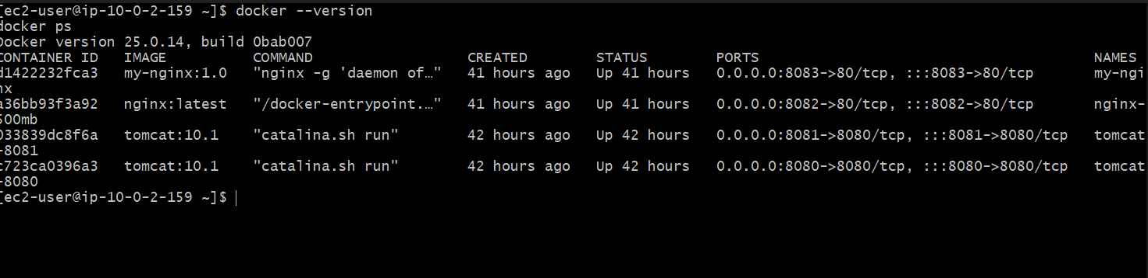
For Task 8, use your Jenkins server/agent where Docker is available.
Task 1 — Create an image from the running my-nginx container
Step 1: Check the current container
Run: docker inspect my-nginx --format '{{.Config.Image}}'
Expected: my-nginx:1.0
Step 2: Make a change inside the running container
Enter it: docker exec -it my-nginx bash
Inside the container, run: echo "This image was created from a running container" > /usr/share/nginx/html/index.html
Verify: cat /usr/share/nginx/html/index.html
You should see: This image was created from a running container
Exit: exit
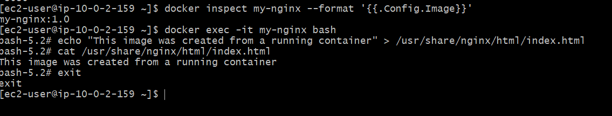
Step 3: Test the running container
Because your container is mapped to port 8083: curl http://localhost:8083
Expected: This image was created from a running container
Step 4: Create the new image
Now commit the running container: docker commit my-nginx my-nginx-from-container:1.0
Expected output will look similar to: sha256:xxxxxxxxxxxxxxxxxxxxxxxx
Step 5: Verify the image
docker images
You should now have: my-nginx-from-container 1.0
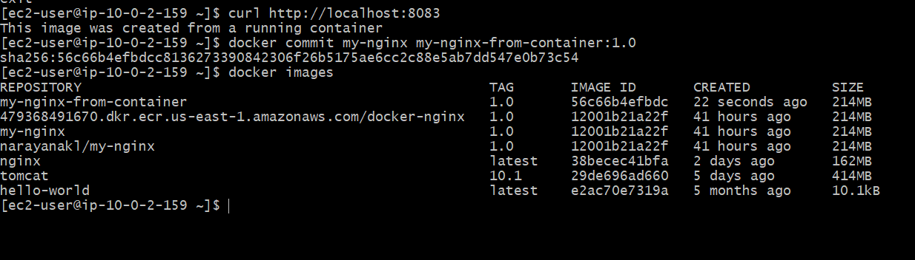
Final verification
Run: docker run -d --name my-nginx-committed -p 8084:80 my-nginx-from-container:1.0
Then: docker ps And test: curl http://localhost:8084
If you previously created the /usr/share/nginx/html/index.html modification, you should see: This image was created from a running container
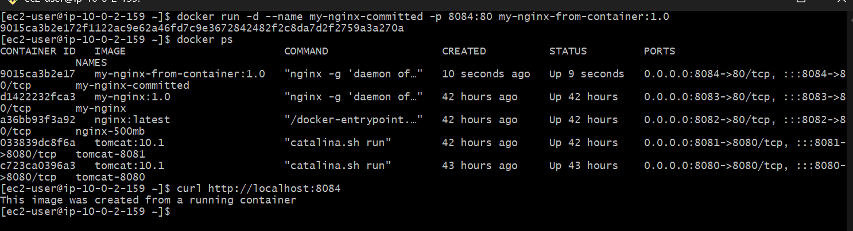
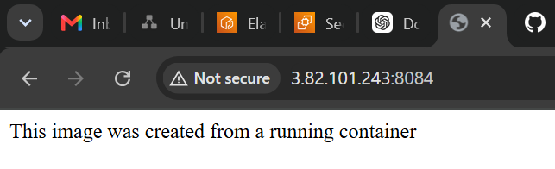
Then clean up only the test container: docker rm -f my-nginx-committed
Your original containers remain untouched.
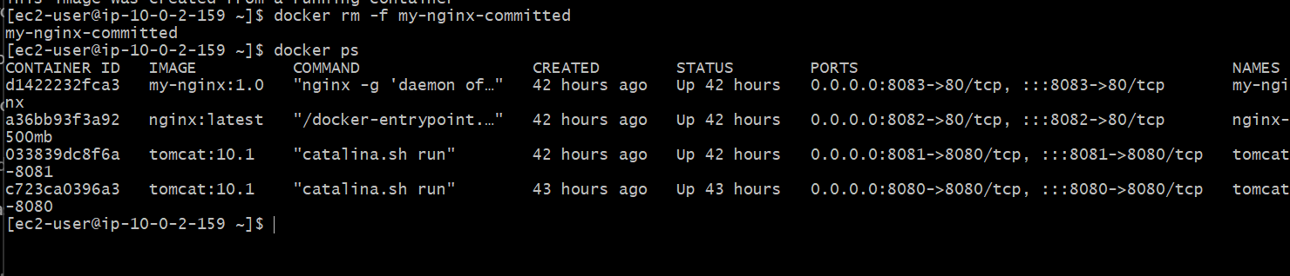2. Copy image from local machine to Docker server and load it
We will use: my-nginx-from-container:1.0
Step 1 — Save the image as a .tar file
Run on your current Docker server: docker save -o my-nginx-from-container.tar my-nginx-from-container:1.0
Now check the file: ls -lh my-nginx-from-container.tar
You should see something similar to: -rw------- 1 ec2-user ec2-user 214M Aug 27 11:xx my-nginx-from-container.tar
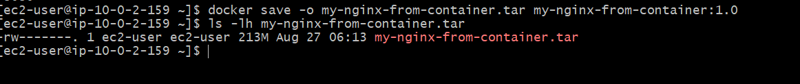
Step 2 — Verify the image archive
Run: file my-nginx-from-container.tar
You should get output indicating it is a Docker image archive/tar file.
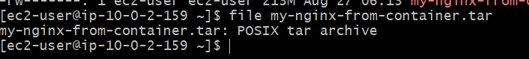
Important
For the actual copy portion of this task, we need a second Docker server.
Your current server is: ip-10-0-2-159
Verify the key
In Command Prompt: dir "C:\Users\Narayana KL\Downloads\jenkins.pem"
You should see the file.
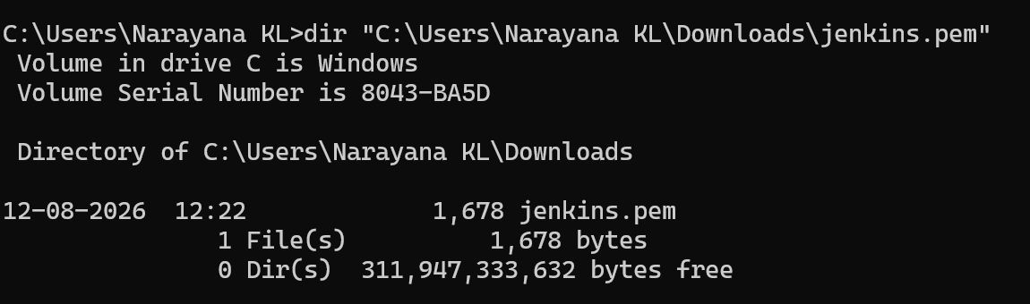
Step 2 — Copy the Docker image from EC2 to Windows
Use: scp -i "C:\Users\Narayana KL\Downloads\jenkins.pem" ec2-user@YOUR_EC2_PUBLIC_IP:/home/ec2-user/my-nginx-from-container.tar "C:\Users\Narayana KL\Downloads"
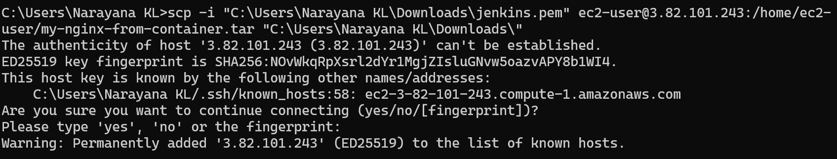Run this exact command
scp -i "C:\Users\Narayana KL\Downloads\jenkins.pem" ec2-user@3.82.101.243:/home/ec2-user/my-nginx-from-container.tar "C:\Users\Narayana KL\Downloads"
Notice there is no \ after Downloads inside the quotes.
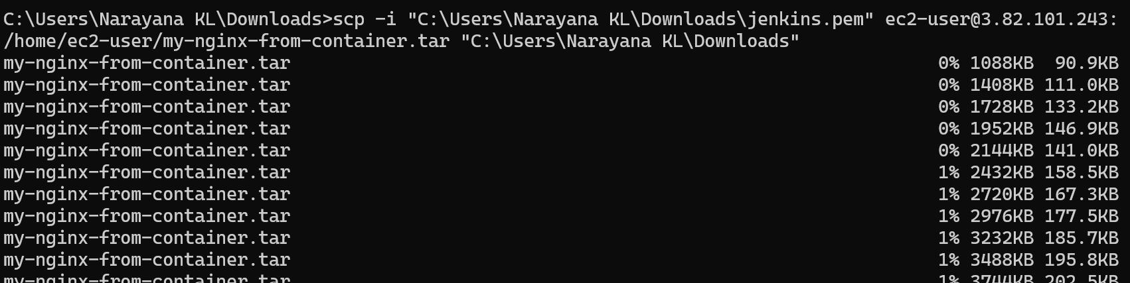
You should then see something similar to:
my-nginx-from-container.tar 100% 213MB ... ...
Verify the file
After scp completes: dir "C:\Users\Narayana KL\Downloads\my-nginx-from-container.tar"
Expected size should be around: 213 MB
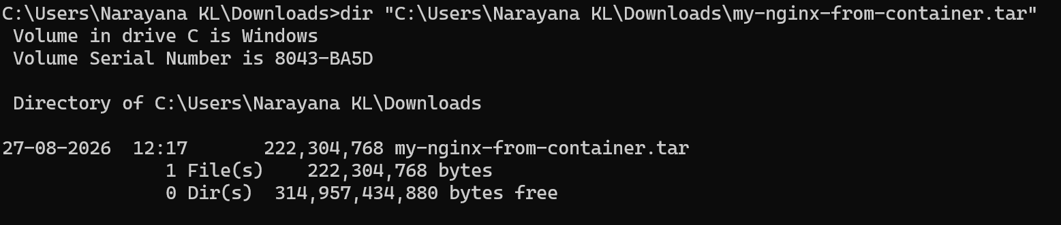
Then load it into Docker Desktop
Only after the copy succeeds: docker load -i "C:\Users\Narayana KL\Downloads\my-nginx-from-container.tar"
Expected: Loaded image: my-nginx-from-container:1.0
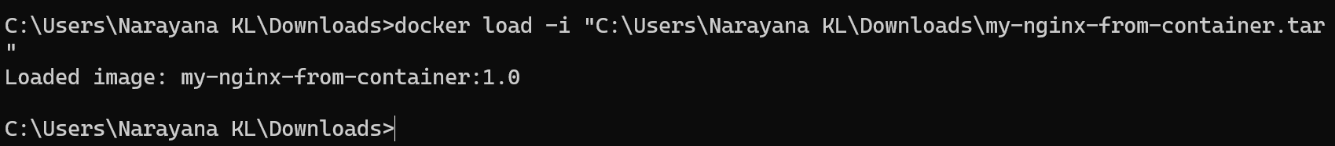
Then: docker images
You should see: my-nginx-from-container 1.0
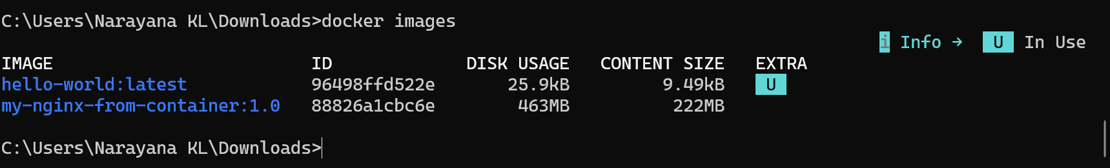
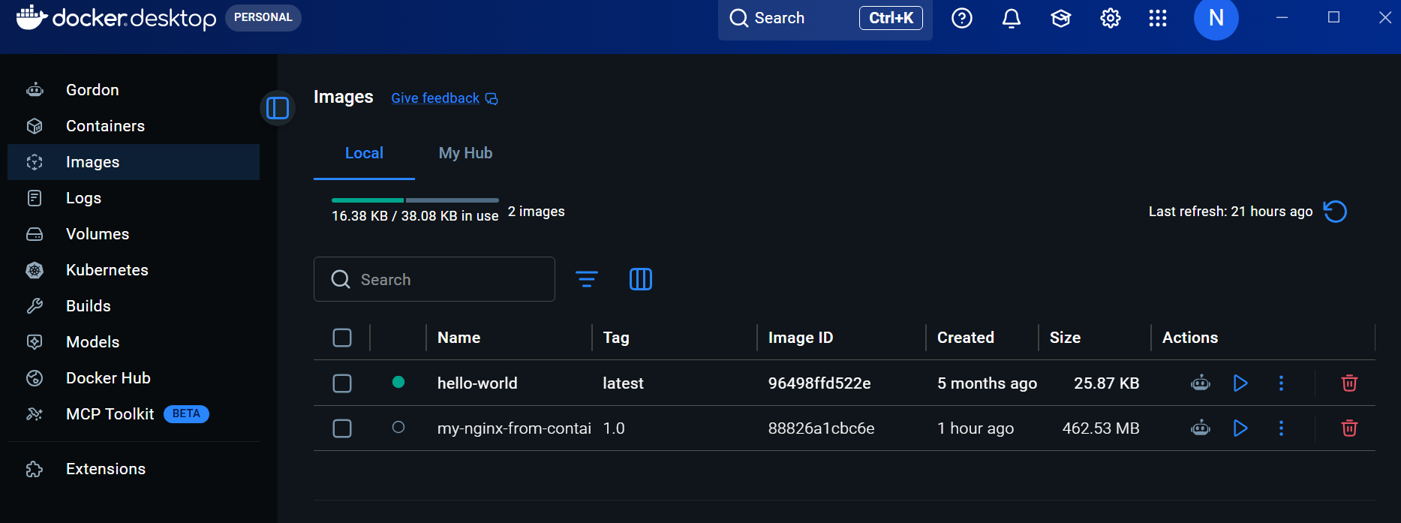
Docker Desktop now has: my-nginx-from-container:1.0
So the complete transfer worked:
EC2 Docker Server
│
│ docker save
▼
my-nginx-from-container.tar
│
│ SCP
▼
Windows Downloads
│
│ docker load
▼
Docker Desktop
│
▼
my-nginx-from-container:1.0
Your Docker Desktop output confirms the image is loaded:
my-nginx-from-container:1.0
DISK USAGE: 463MB
CONTENT SIZE: 222MB
The difference between the .tar file's ~213 MB and Docker Desktop's disk usage is normal because Docker stores the image layers differently after loading.
Final verification
Let's actually run the transferred image on Docker Desktop.
Run in Command Prompt: docker run -d --name transferred-nginx -p 8085:80 my-nginx-from-container:1.0
Then: docker ps
You should see: transferred-nginx
0.0.0.0:8085->80/tcp
Now test: curl http://localhost:8085
Expected: This image was created from a running container
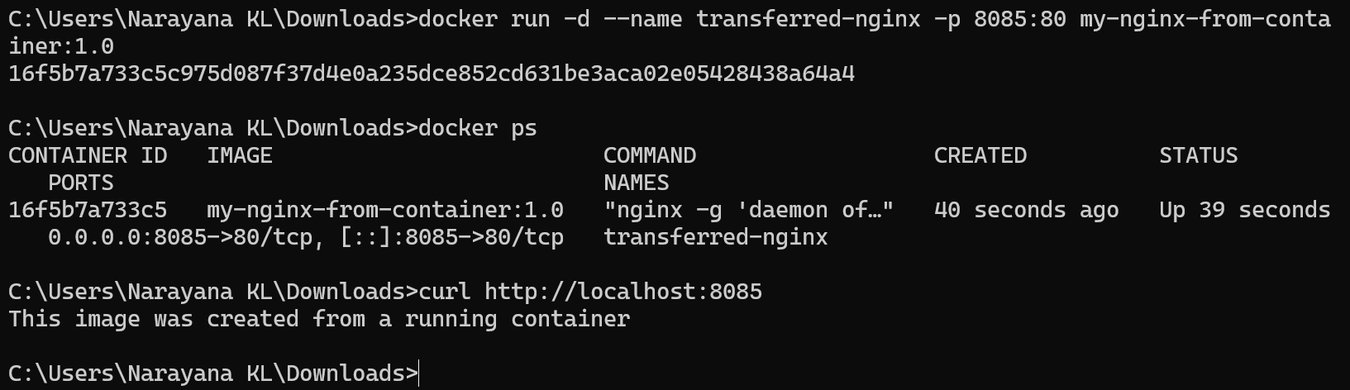
If that works, Task 2 is completely verified.
Then clean up: docker rm -f transferred-nginx
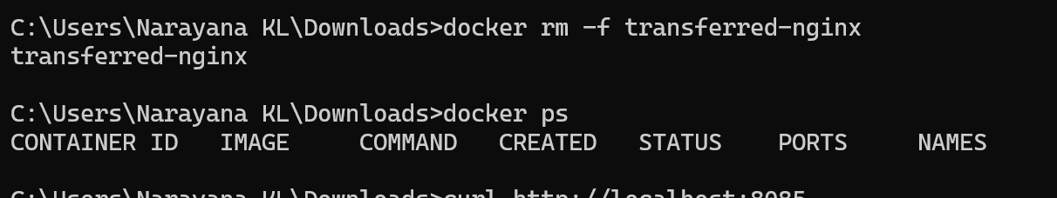
3. Create Docker image using Alpine and customize with Tomcat
Here we will create a custom Tomcat image using Alpine Linux.
Important note Tomcat requires Java, so our image will contain:
Alpine
↓
Java
↓
Tomcat
Step 1 — Create a working directory
On the EC2 server: mkdir -p ~/alpine-tomcat
cd ~/alpine-tomcat
Verify: pwd
Expected: /home/ec2-user/alpine-tomcat
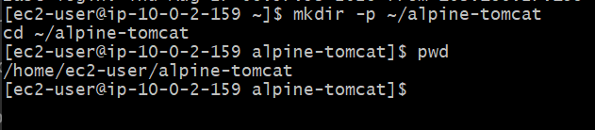

Step 2 — Create the Dockerfile
Run: vi Dockerfile
Paste: FROM alpine:3.20
RUN apk add --no-cache openjdk17-jre wget
ENV CATALINA_HOME=/opt/tomcat
ENV PATH=$CATALINA_HOME/bin:$PATH
RUN wget -q https://dlcdn.apache.org/tomcat/tomcat-10/v10.1.50/bin/apache-tomcat-10.1.50.tar.gz \
-O /tmp/tomcat.tar.gz && \
mkdir -p /opt && \
tar -xzf /tmp/tomcat.tar.gz -C /opt && \
mv /opt/apache-tomcat-10.1.50 /opt/tomcat && \
rm /tmp/tomcat.tar.gz
EXPOSE 8080
CMD ["catalina.sh", "run"]
Save and exit: ESC :wq
ENTER
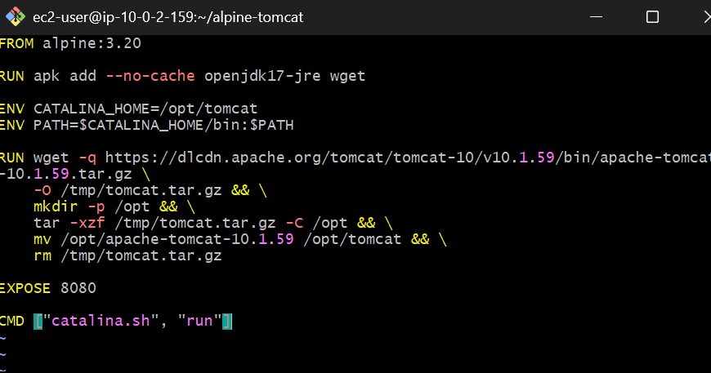
Before building, verify the file
cat Dockerfile
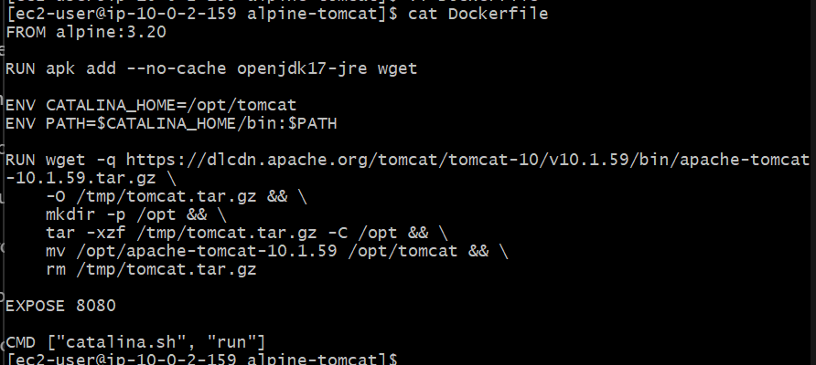
Step 3 — Build the image
Run: docker build -t alpine-tomcat:1.0 .
This will take a little time because it needs to:
- Download Alpine
- Install Java
- Download Tomcat
- Extract Tomcat
- Create the final image
When successful, you should see: Successfully tagged alpine-tomcat:1.0
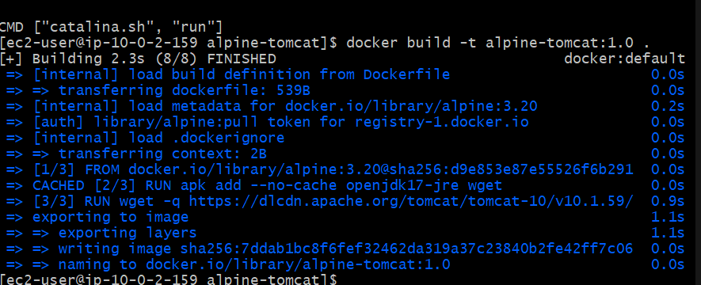

Step 4 — Verify the image
docker images alpine-tomcat
You should see something similar to:
REPOSITORY TAG IMAGE ID CREATED SIZE
alpine-tomcat 1.0 xxxxxxxxxxxx seconds ago ...
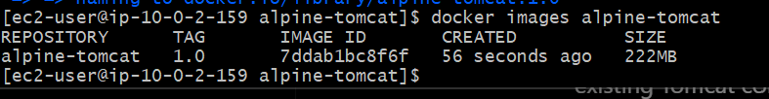
Now let's verify that Tomcat actually runs.
Step 5 — Run the container
Use port 8085 so we don't conflict with your existing containers on 8080 and 8081:
docker run -d --name alpine-tomcat -p 8085:8080 alpine-tomcat:1.0
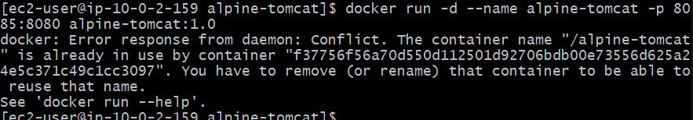
Check: docker ps
You should see: alpine-tomcat alpine-tomcat:1.0 0.0.0.0:8085->8080/tcp
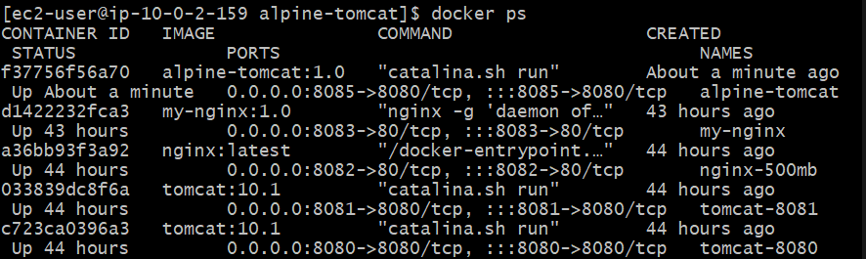
Step 6 — Check Tomcat logs
docker logs alpine-tomcat
Look for a message indicating: Server startup
and Tomcat listening on port 8080 inside the container.
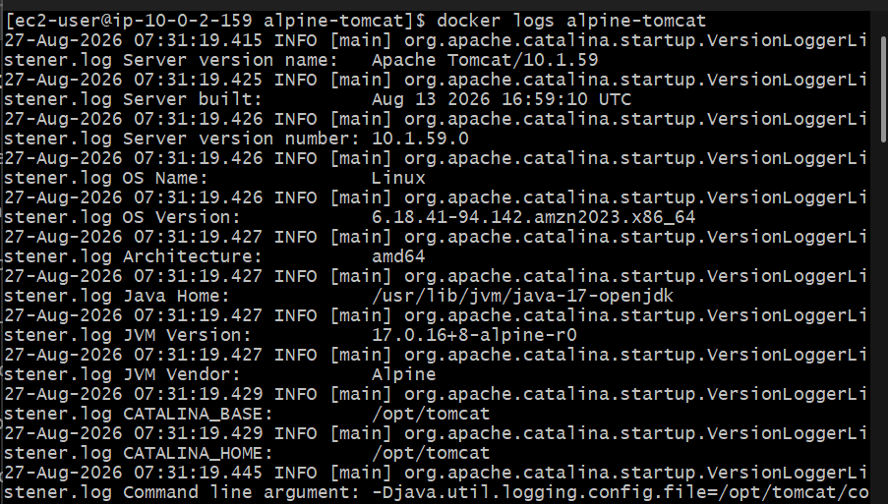
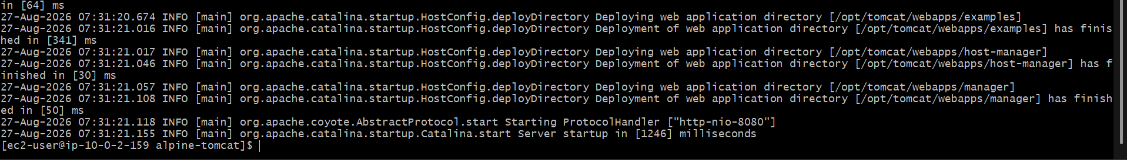
Step 7 — Test Tomcat
From the EC2 server: curl http://localhost:8085
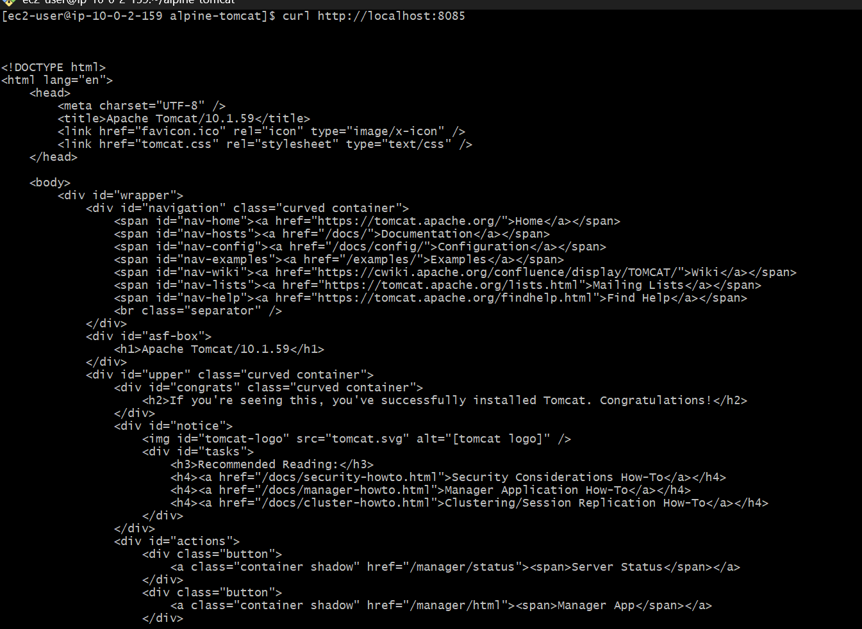
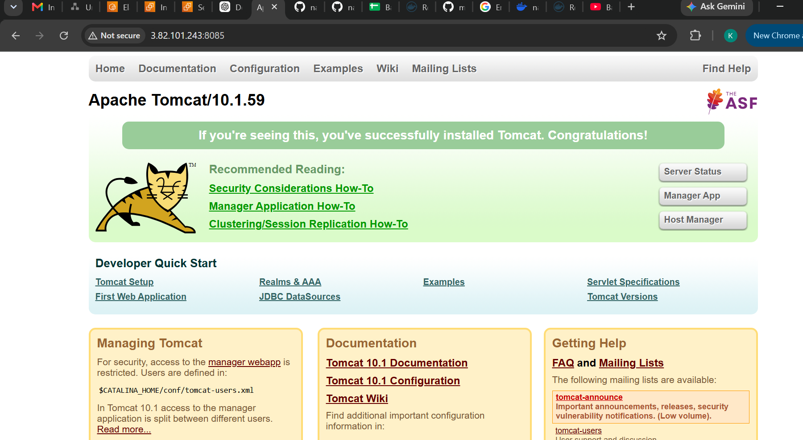
You should receive the Tomcat default page HTML.
Step 8 — Verify Java
docker exec alpine-tomcat java -version
You should see OpenJDK 17.
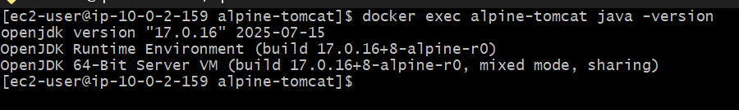
Step 9 — Verify Alpine
docker exec alpine-tomcat cat /etc/alpine-release
Expected: 3.20.x
Step 10 — Verify Tomcat
docker exec alpine-tomcat catalina.sh version
You should see: Server version: Apache Tomcat/10.1.59
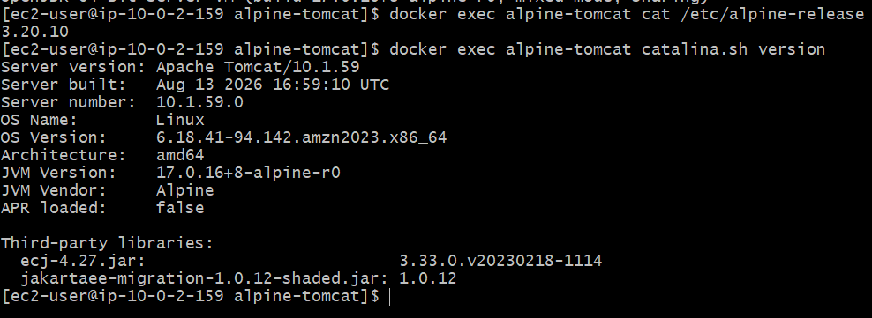

Task 4 — Single-stage and Multi-stage Dockerfiles
Source:
betawins/multi-stage-example GitHub repository
We'll do this carefully because the important part of this task is understanding the difference between the two Dockerfiles.
Step 1 — Clone the source repository
Go back to your home directory: cd ~
Clone: git clone https://github.com/betawins/multi-stage-example.git
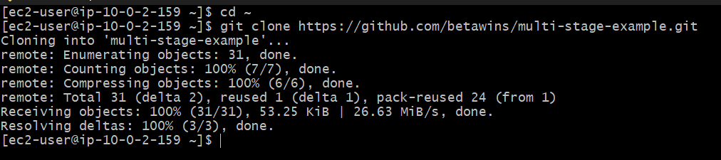
Then: cd multi-stage-example
Check the files: ls -la
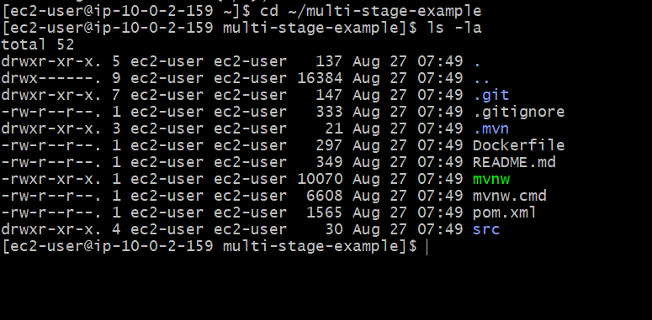
And: find . -maxdepth 2 -type f
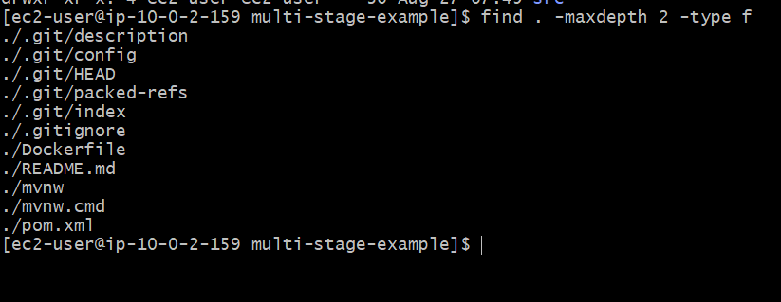
Task 4A — Single-stage Dockerfile
First, create a separate file so we don't overwrite the repository's original Dockerfile.
Run: cd ~/multi-stage-example
Create: vi Dockerfile.single
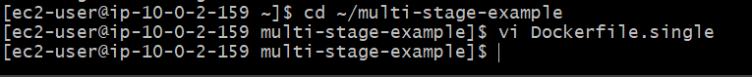
Paste: FROM openjdk:8-jdk-alpine
WORKDIR /app
COPY . .
RUN ./mvnw clean package
EXPOSE 8080
ENTRYPOINT ["java", "-Djava.security.egd=file:/dev/./urandom", "-jar", "/app/target/multi-stage-example-0.0.1-SNAPSHOT.jar"]
Save: Esc :wq
Enter
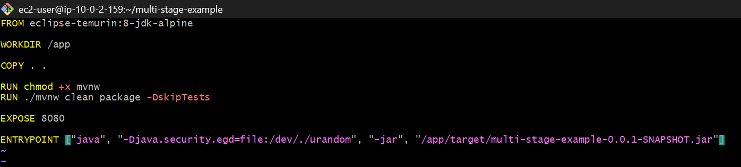
Build the single-stage image
docker build -f Dockerfile.single -t multi-stage-single:v1 .
This will download Maven dependencies and build the Spring Boot application.
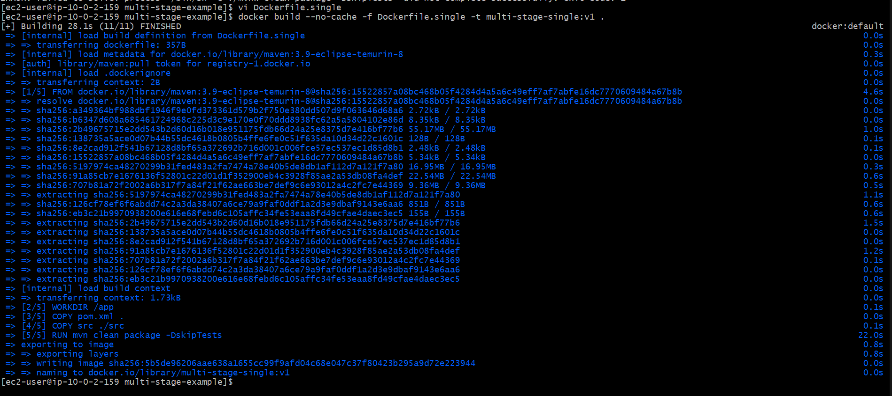
Check the image
docker images | grep multi-stage
You should see: multi-stage-single v1 ...
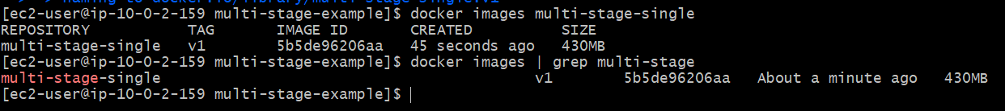
Task 4B — Create the proper multi-stage Dockerfile
Now create: vi Dockerfile.multi
Use this: FROM maven:3.9-eclipse-temurin-8 AS builder
WORKDIR /app
COPY pom.xml .
COPY src ./src
RUN mvn clean package -DskipTests
FROM eclipse-temurin:8-jre-alpine
WORKDIR /app
COPY --from=builder /app/target/*.jar app.jar
EXPOSE 8080
ENTRYPOINT ["java", "-Djava.security.egd=file:/dev/./urandom", "-jar", "app.jar"]
Save: Esc :wq Enter
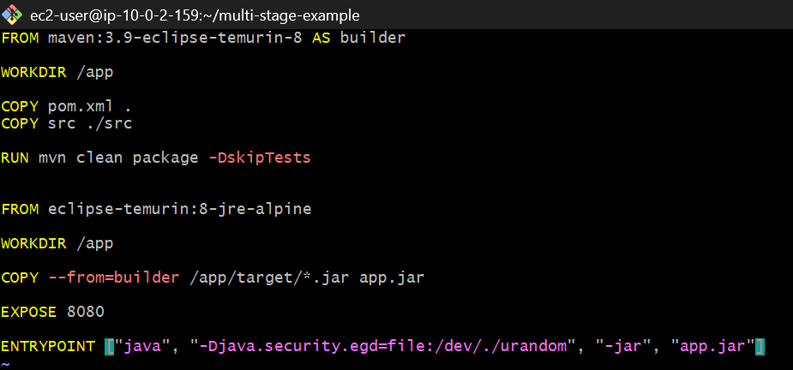
Build the multi-stage image
docker build --no-cache -f Dockerfile.multi -t multi-stage-multi:v1 .
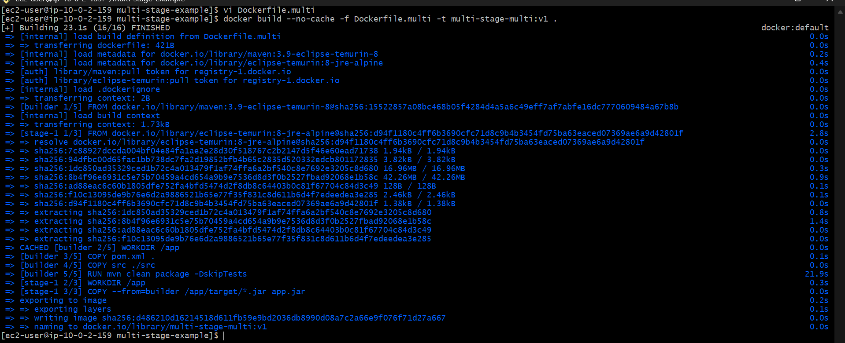
Then compare both images
docker images | grep multi-stage
You should have: multi-stage-single v1 ... 430MB
multi-stage-multi v1 ... <smaller>
The exact multi-stage size may vary.
Why the multi-stage image should be smaller
Single-stage: Maven
JDK
Source code
Maven dependencies
Build artifacts
JAR
↓
430MB image
Multi-stage:
Builder stage
Maven + JDK + source
↓
JAR
↓
Runtime stage
JRE + JAR
The builder stage isn't included in the final image.

After the build succeeds
Run: docker run -d --name multi-stage-app -p 8086:8080 multi-stage-multi:v1
Then: docker ps
And: docker logs multi-stage-app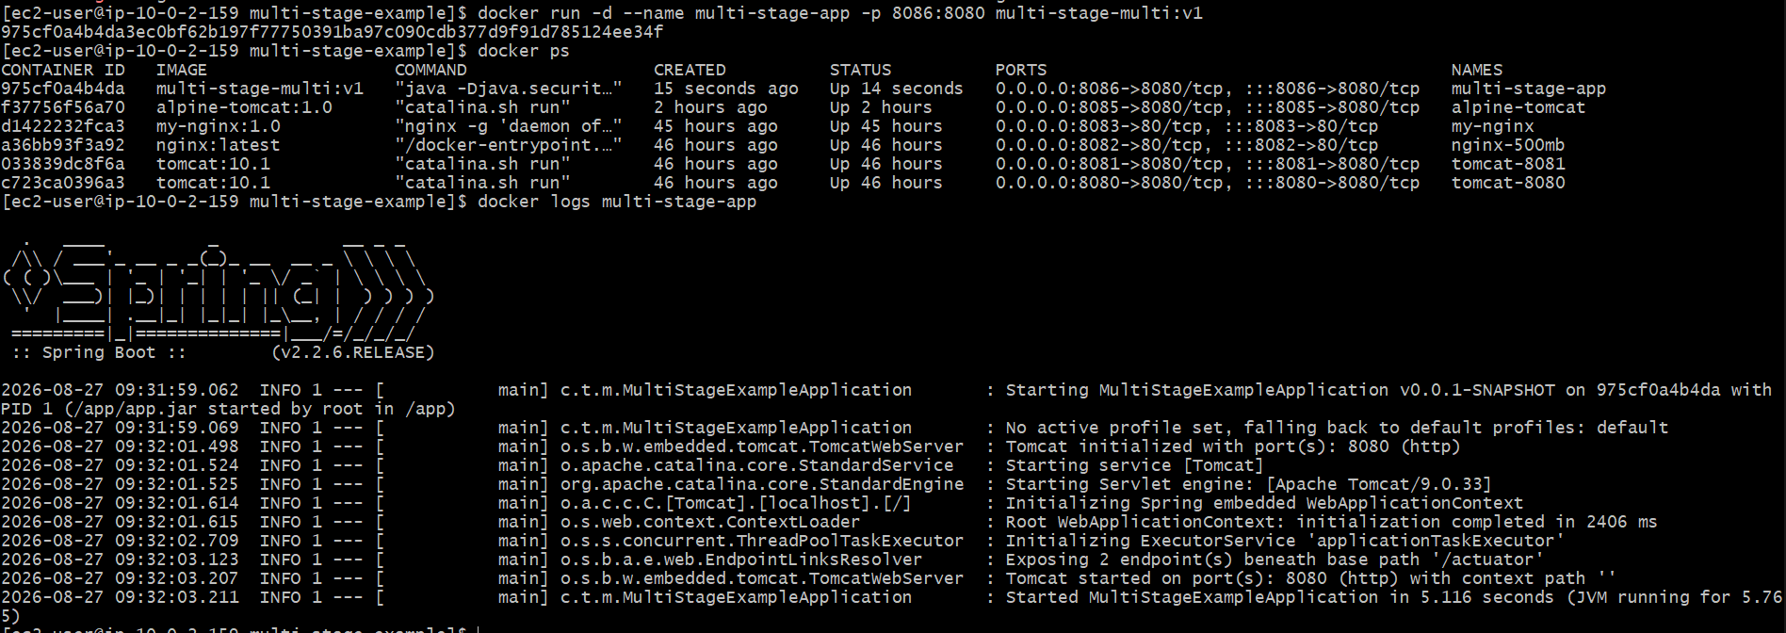
Finally test the application: curl http://localhost:8086/actuator/health
Expected: {"status":"UP"}
Task 5 — Install Docker Compose and execute a sample application
Step 1 — Create the Docker CLI plugin directory
Run: mkdir -p ~/.docker/cli-plugins
Step 2 — Download Docker Compose
Run: curl -SL https://github.com/docker/compose/releases/latest/download/docker-compose-linux-x86_64 \
-o ~/.docker/cli-plugins/docker-compose
Step 3 — Make it executable
chmod +x ~/.docker/cli-plugins/docker-compose
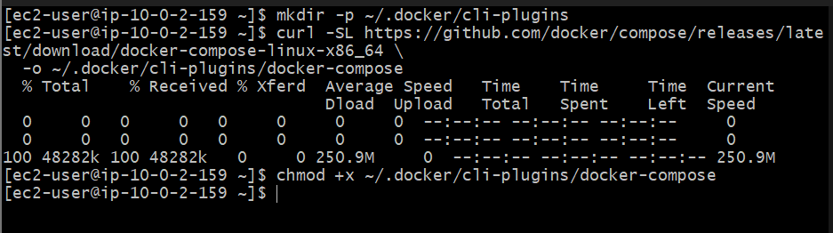
Step 4 — Verify
docker compose version
You should now get something similar to: Docker Compose version v2.x.x
Step 5 — Confirm Docker sees the plugin
docker compose ls
It may show: NAME STATUS CONFIG FILES
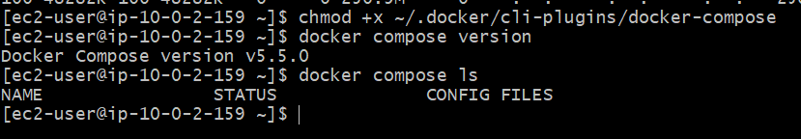
That's fine — we haven't created a Compose project yet.
Step 6 — Create a Compose sample application
Once docker compose version works, we'll create:
~/compose-lab/
├── docker-compose.yml
└── index.html
The Compose application will contain:
Docker Compose
│
┌─────────┴─────────┐
│ │
nginx redis
│
port 8087
We'll use 8087 because your existing containers already occupy 8080–8086.
Execute a sample Docker Compose application
We'll create a simple Nginx + Redis Compose application.
Step 1 — Create the project directory
mkdir -p ~/compose-lab
cd ~/compose-lab
Verify: pwd
Expected: /home/ec2-user/compose-lab
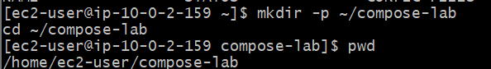
Step 2 — Create index.html
Run:
cat > index.html <<'EOF'
<!DOCTYPE html>
<html>
<head>
<title>Docker Compose Lab</title>
</head>
<body>
<h1>Docker Compose is Working!</h1>
<p>Nginx is running through Docker Compose.</p>
</body>
</html>
EOF
Verify: cat index.html
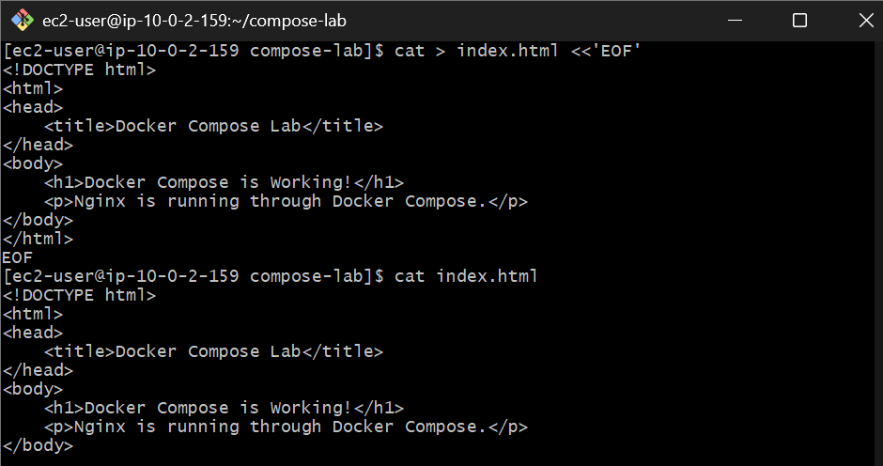
Step 3 — Create docker-compose.yml
Run: vi docker-compose.yml
Paste: services:
nginx:
image: nginx:latest
container_name: compose-nginx
ports:
- "8087:80"
volumes:
- ./index.html:/usr/share/nginx/html/index.html:ro
depends_on:
- redis
redis:
image: redis:latest
container_name: compose-redis
Save: Esc :wq Enter
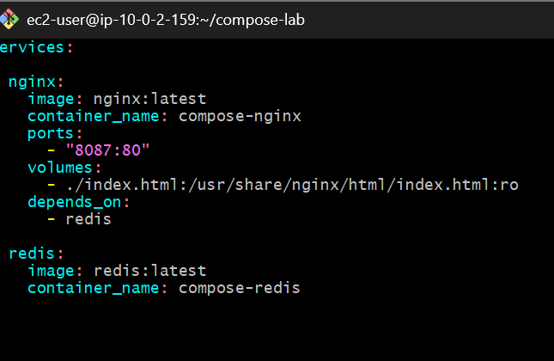
Step 4 — Validate the Compose file
Before starting anything: docker compose config
You should see the expanded Compose configuration without errors.
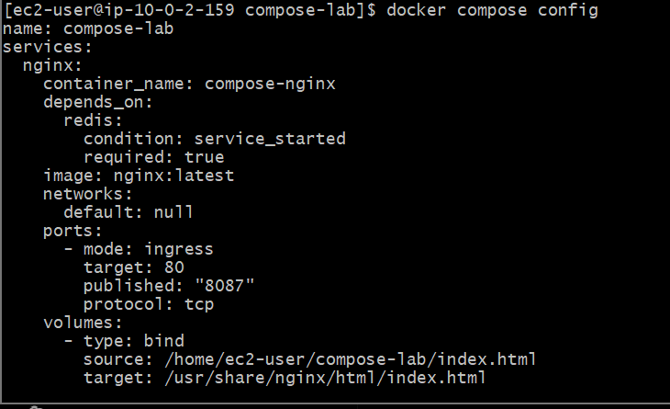
Step 5 — Start the application
docker compose up -d
Expected output will show both containers being created.
Then: docker compose ps
You should see something similar to:
NAME STATUS PORTS
compose-nginx Up 0.0.0.0:8087->80/tcp
compose-redis Up
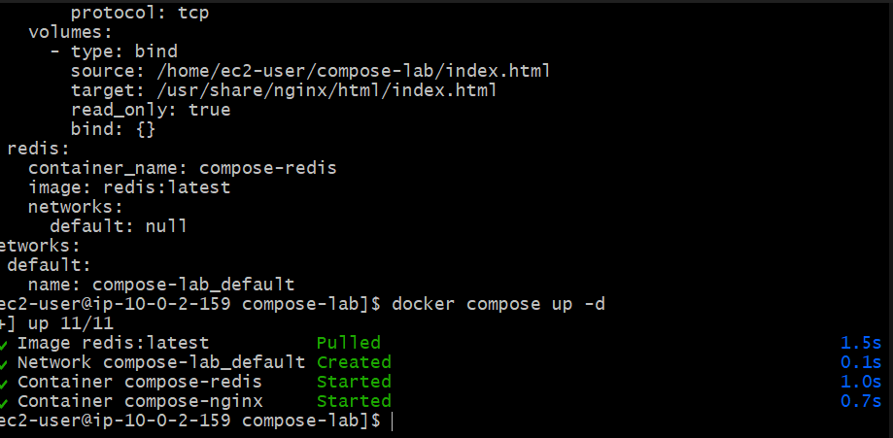Step 6 — Test Nginx
Run: curl http://localhost:8087
Expected: Docker Compose is Working!
Nginx is running through Docker Compose.
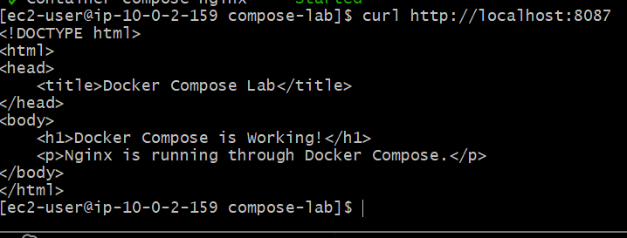
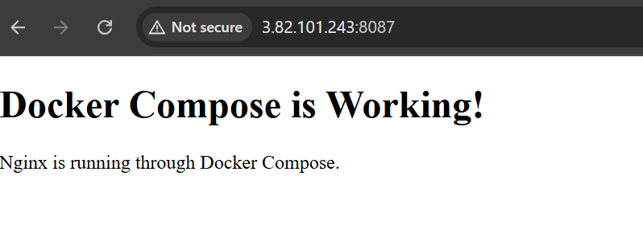

Step 7 — Test Redis
Run: docker exec compose-redis redis-cli ping
Expected: PONG
Step 8 — Check Compose project
docker compose ls
Now you should see:
NAME STATUS
compose-lab running
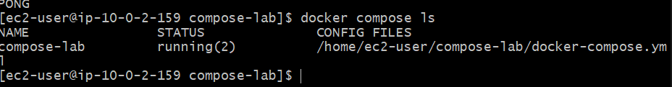
Step 9 — View logs
docker compose logs
Or only Nginx:
docker compose logs nginx
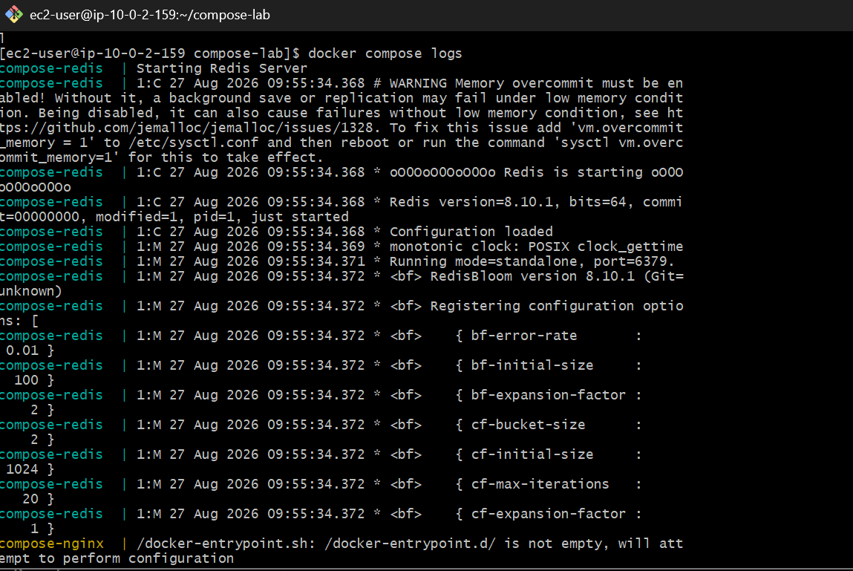

6. Scan images when pushed to Docker registry
A good lab implementation is:
Developer
↓
Docker build
↓
Trivy scan
↓
If SAFE
↓
Docker Hub push
If vulnerabilities above your policy are found:
Trivy
↓
FAIL
↓
Do NOT push
Step 1 — Check your Docker path
Run: which docker
You should get something like: /usr/bin/docker
Then: docker version --format '{{.Client.Version}}'
Step 2 — Install Scout without sudo
Run: mkdir -p ~/.docker/cli-plugins
Then: curl -fsSL https://raw.githubusercontent.com/docker/scout-cli/main/install.sh | sh
This time do not use sudo.
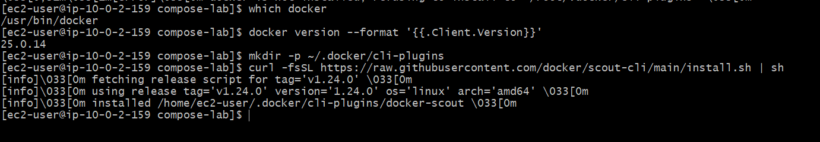
Step 3 — Verify
docker scout version
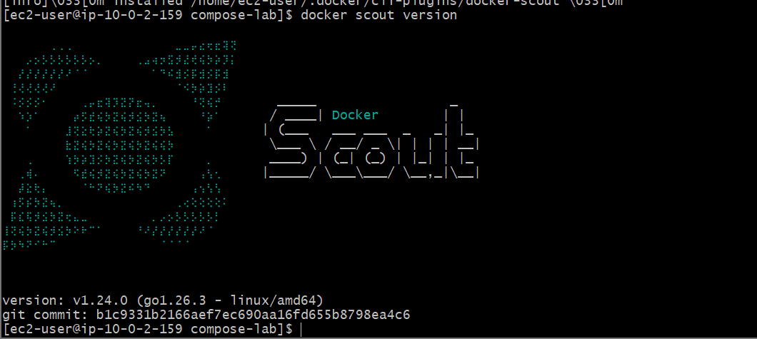
If it works, we'll immediately scan: docker scout quickview my-nginx:1.0
and: docker scout cves my-nginx:1.0
If the installer still complains
Don't keep retrying it. Run: ls -l ~/.docker/cli-plugins/
and: echo $PATH

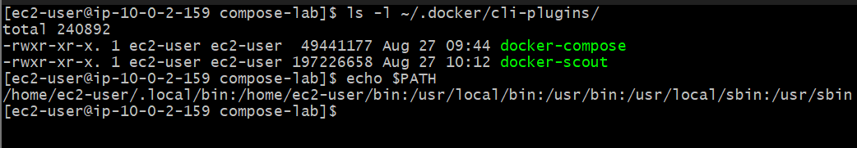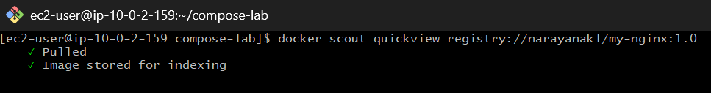

Scan the Docker Hub image
You already have: narayanakl/my-nginx:1.0
Run: docker scout quickview registry://narayanakl/my-nginx:1.0
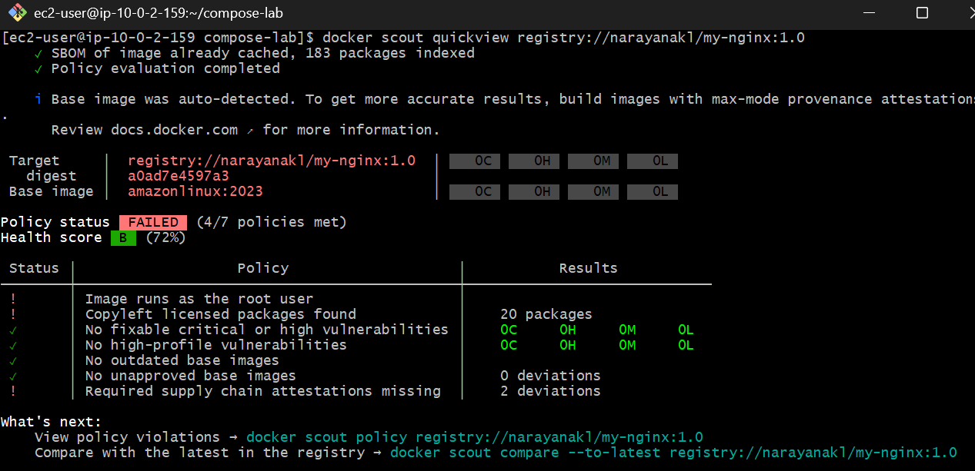
This tells Scout: Don't use the local image. Get narayanakl/my-nginx:1.0 from the registry.
Then run: docker scout cves registry://narayanakl/my-nginx:1.0
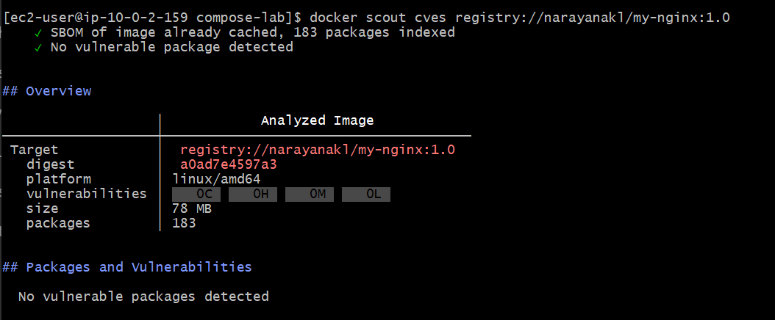
✅ Task 6 is fully completed.
Your Docker Hub image: narayanakl/my-nginx:1.0 was successfully scanned directly from the registry using Docker Scout.
Final Task 6 result
SBOM packages : 183
Critical : 0
High : 0
Medium : 0
Low : 0
Vulnerable packages : 0
Health score : B (72%)
The important security result is:
No vulnerable packages detected
7. Scan images when pushed to AWS ECR
You already have the ECR repository from our earlier lab:
479368491670.dkr.ecr.us-east-1.amazonaws.com/docker-nginx
And your image: my-nginx:1.0
Let's now configure Amazon ECR vulnerability scanning.
Step 1 — Check ECR repository
Run: aws ecr describe-repositories \
--repository-names docker-nginx \
--region us-east-1
You should see the repository details.
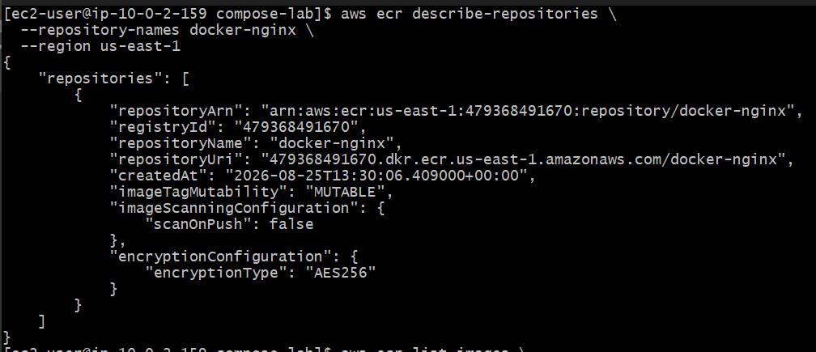
Step 2 — Check current image
Run: aws ecr list-images \
--repository-name docker-nginx \
--region us-east-1
You should see your existing image tag:
1.0
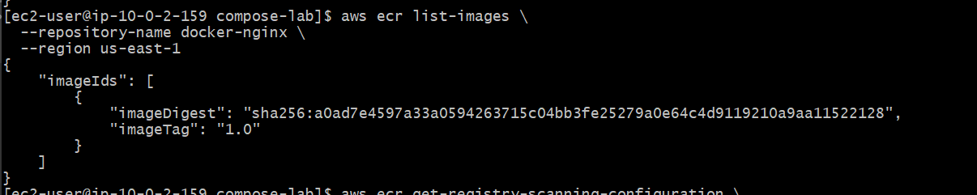
Step-3 :Create an inline policy for the role
In AWS Console:
IAM → Roles → DockerLab-ECR-Role → Add permissions → Create inline policy
Select the JSON tab and paste:
{
"Version": "2012-10-17",
"Statement": [
{
"Sid": "ECRScanningConfiguration",
"Effect": "Allow",
"Action": [
"ecr:GetRegistryScanningConfiguration",
"ecr:PutRegistryScanningConfiguration"
],
"Resource": "*"
}
]
}
These are registry-level permissions, so "Resource": "*" is appropriate. AWS lists both actions as ECR registry scanning configuration actions.
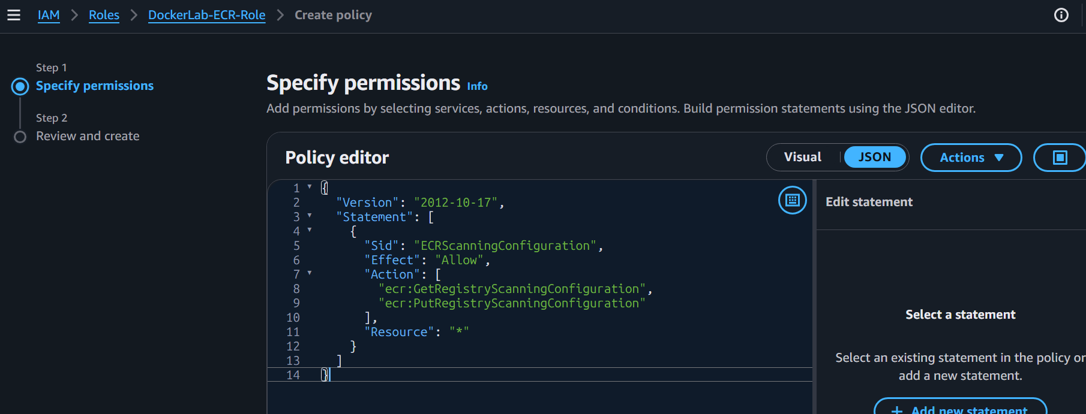
Name it:ECRScanningConfigurationPolicy
Then Create policy.
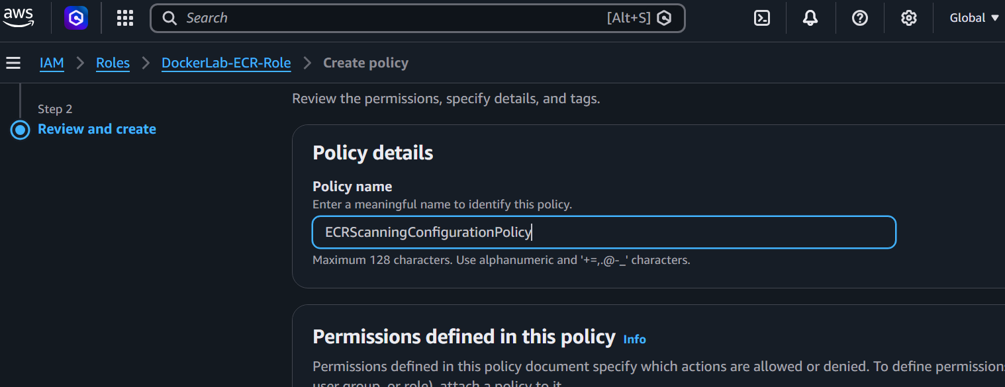
Update the inline policy
Go to: IAM → Roles → DockerLab-ECR-Role → Permissions → ECRScanningConfigurationPolicy → Edit
Change the JSON to:
{
"Version": "2012-10-17",
"Statement": [
{
"Sid": "ECRScanningConfiguration",
"Effect": "Allow",
"Action": [
"ecr:GetRegistryScanningConfiguration",
"ecr:PutRegistryScanningConfiguration"
],
"Resource": "*"
},
{
"Sid": "ECRStartImageScan",
"Effect": "Allow",
"Action": [
"ecr:StartImageScan"
],
"Resource": "arn:aws:ecr:us-east-1:479368491670:repository/docker-nginx"
}
]
}
Click Next → Save changes
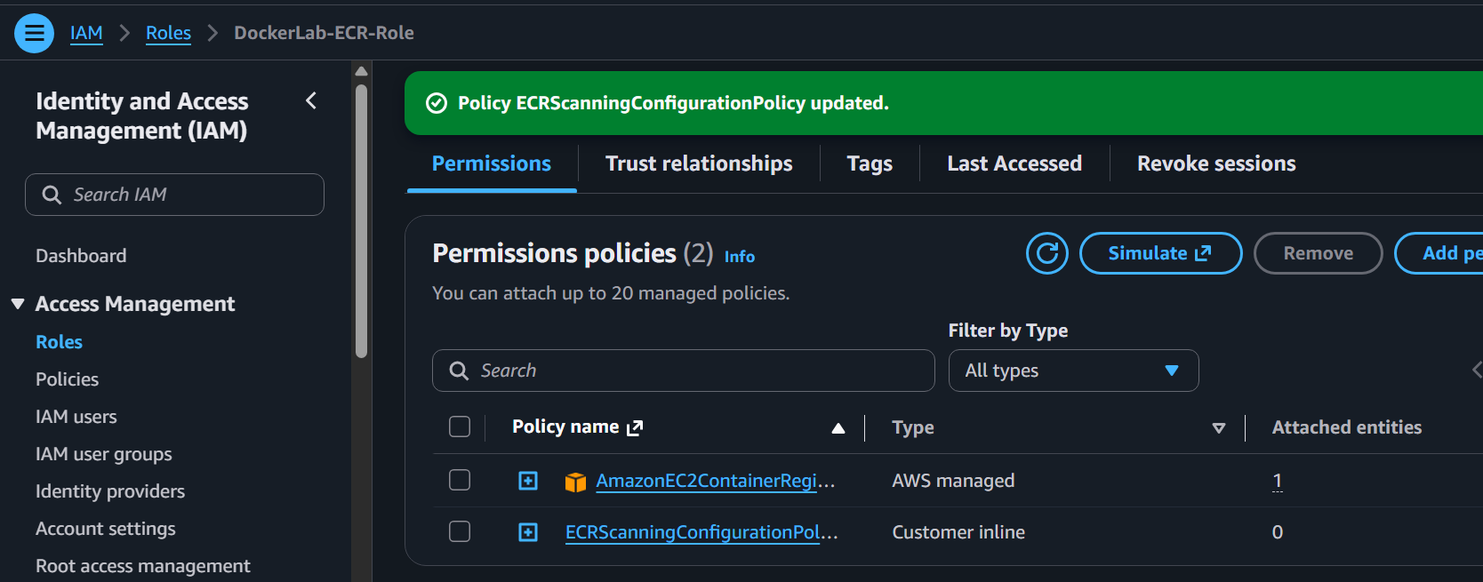
Step 4 — Test it
Wait a few seconds after saving, then on the EC2 server run:
aws ecr get-registry-scanning-configuration \
--region us-east-1
Expected
You should now get something like:
{
"registryId": "479368491670",
"scanningConfiguration": {
"scanType": "BASIC",
"rules": []
}
}
The exact output may differ. ECR currently supports BASIC and ENHANCED scanning, with SCAN_ON_PUSH available for both; enhanced scanning can also use continuous scanning.
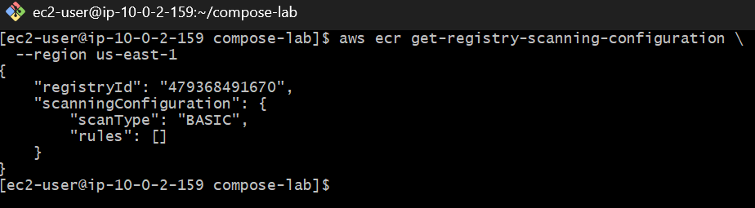
Step — Enable scan-on-push
Run: aws ecr put-registry-scanning-configuration \
--scan-type BASIC \
--rules '[{"scanFrequency":"SCAN_ON_PUSH","repositoryFilters":[{"filter":"docker-nginx","filterType":"WILDCARD"}]}]' \
--region us-east-1
You should get a successful JSON response showing the rule.
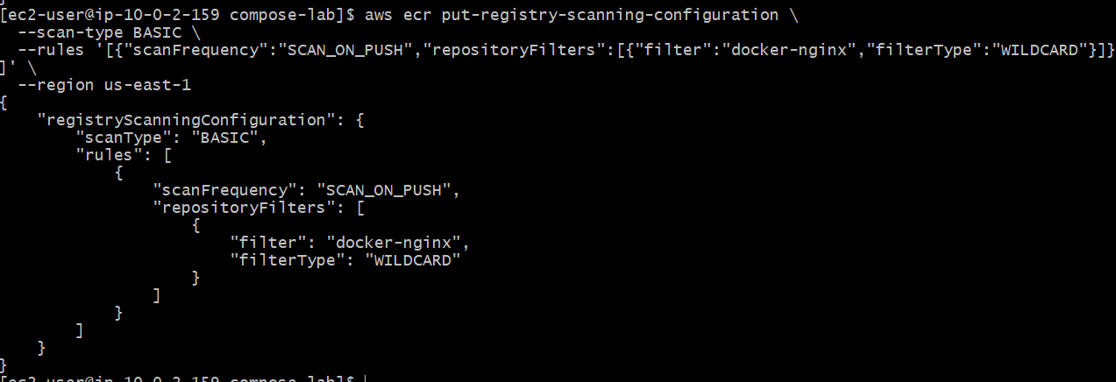
Step 6 — Verify
Run:aws ecr get-registry-scanning-configuration \
--region us-east-1
We want to see something similar to:
scanType: BASIC
scanFrequency: SCAN_ON_PUSH
filter: docker-nginx
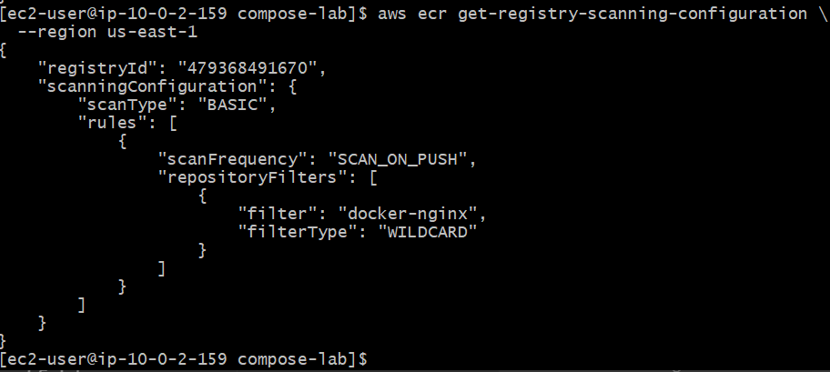
Step 7 — Push a fresh image
Your image already exists: docker images my-nginx:1.0
Tag it for ECR: docker tag my-nginx:1.0 \
479368491670.dkr.ecr.us-east-1.amazonaws.com/docker-nginx:1.0
Login: aws ecr get-login-password --region us-east-1 | \
docker login --username AWS --password-stdin \
479368491670.dkr.ecr.us-east-1.amazonaws.com
Then push: docker push \
479368491670.dkr.ecr.us-east-1.amazonaws.com/docker-nginx:1.0
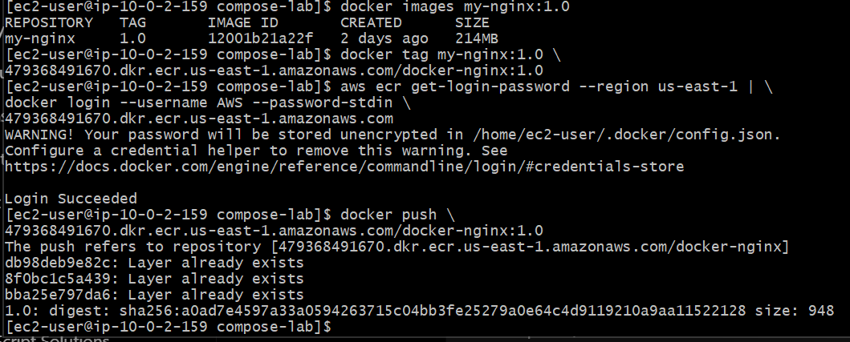
Step 8 — Start the scan again
Back on EC2:aws ecr start-image-scan \
--repository-name docker-nginx \
--image-id imageTag=1.0 \
--region us-east-1
Expected: imageScanStatus: status: IN_PROGRESS
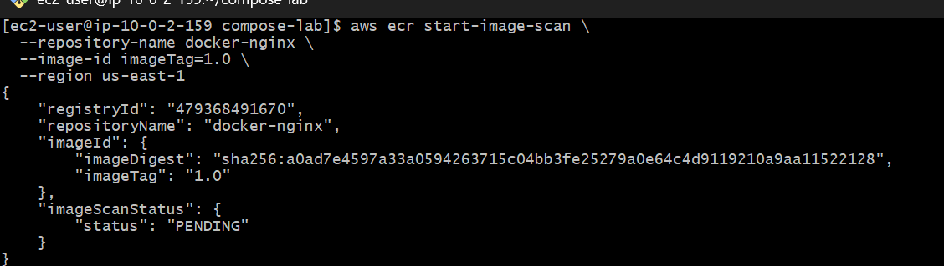
Step 9 — Wait and retrieve findings
Wait about 30–60 seconds, then:
aws ecr describe-image-scan-findings \
--repository-name docker-nginx \
--image-id imageTag=1.0 \
--region us-east-1
You should eventually receive:
imageScanStatus
findingSeverityCounts
findings
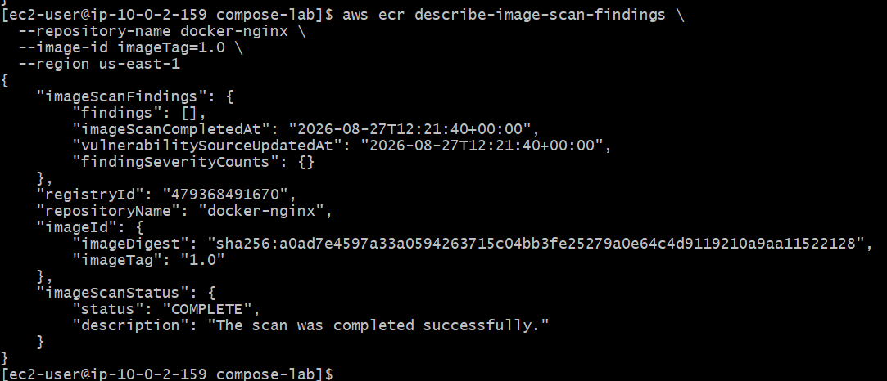
Tag for Docker Hub
docker tag my-nginx:1.1 narayanakl/my-nginx:1.1
Verify: docker images | grep my-nginx
You should see: my-nginx 1.1
narayanakl/my-nginx 1.1
Step 2 — Push to Docker Hub
docker push narayanakl/my-nginx:1.1
At the end, you should get something like:
1.1: digest: sha256:XXXXXXXX...
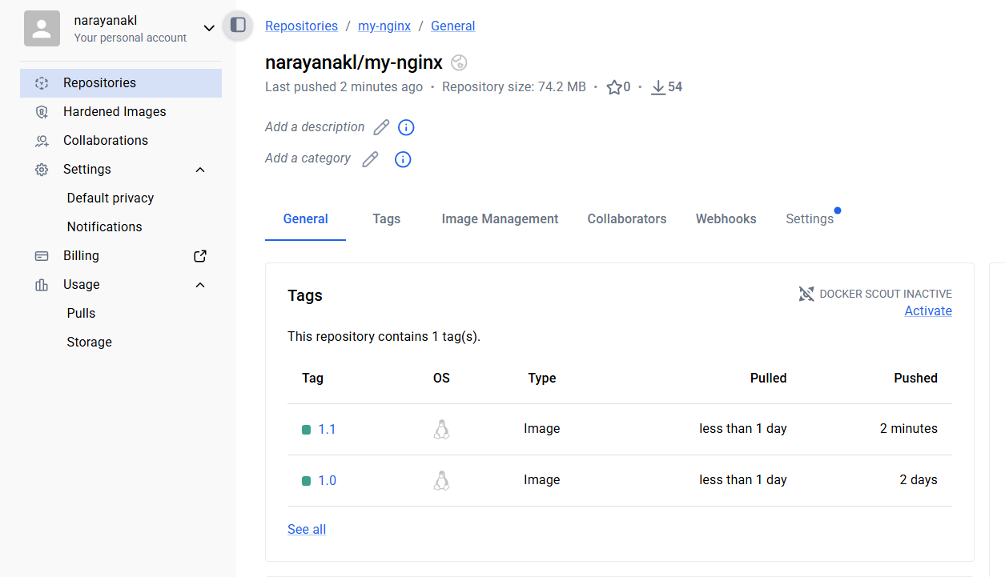
Step 3 — Tag for ECR
docker tag my-nginx:1.1 \
479368491670.dkr.ecr.us-east-1.amazonaws.com/docker-nginx:1.1
Verify: docker images | grep docker-nginx
Step 4 — Make sure you're logged into ECR
aws ecr get-login-password --region us-east-1 | \
docker login --username AWS --password-stdin \
479368491670.dkr.ecr.us-east-1.amazonaws.com
You should get: Login Succeeded
Step 5 — Push 1.1 to ECR
docker push \ 479368491670.dkr.ecr.us-east-1.amazonaws.com/docker-nginx:1.1
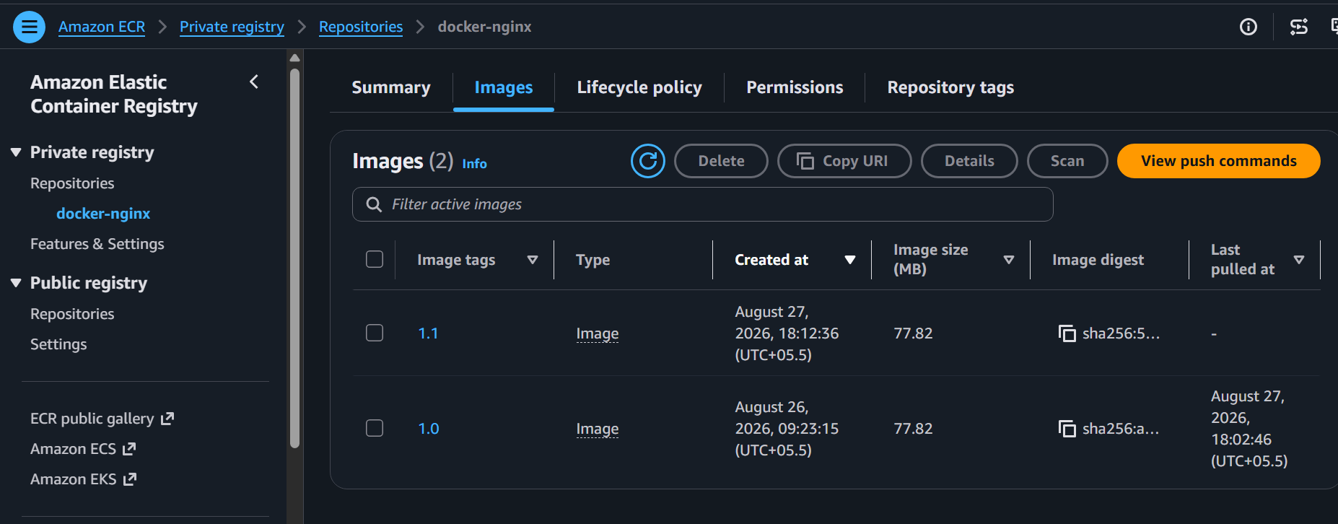
Task 8 — Create a Jenkins pipeline to create a docker image and push the image to Docker hub.
Task 8 — Jenkins Pipeline to Build Docker Image and Push to Docker Hub
Objective
Create a Jenkins Pipeline that will:
GitHub Repository
↓
Jenkins
↓
slave-01
↓
Docker Build
↓
Docker Login
↓
Docker Push
↓
Docker Hub
We'll use your existing Docker Hub repository: narayanakl/my-nginx
and the GitHub project: https://github.com/betawins/multi-stage-example.git

Part 1 — Prerequisites
We need these prerequisites before creating the Jenkins job.
1. Required EC2 instances
Based on your current setup:
Instance | Purpose | Required?
Jenkins-Master | Jenkins controller | ✅ Yes
slave-01 | Pipeline execution + Docker build | ✅ Yes
Docker-server | Separate Docker lab | ❌ Not required
slave-02 | Offline | ❌ Not required
Your Jenkins dashboard already shows:
Built-In Node Online
slave-01 Online / In sync
slave-02 Offline
So we're good.Part 2 — Verify slave-01
Because we want Docker commands to run on slave-01, Jenkins must be able to execute Docker there.
Go to: Jenkins → Manage Jenkins → Nodes → slave-01
Confirm: Status: Online
Architecture: Linux (amd64)
You already have this, so continue.

Part 3 — Check Docker on slave-01
We need Docker installed on slave-01.
You don't need the EC2 .pem file if Jenkins is already connected to the agent.
Create a temporary Pipeline.
Go to: Jenkins → New Item
Enter: Test-Slave-Docker
Select: Pipeline
Click OK.
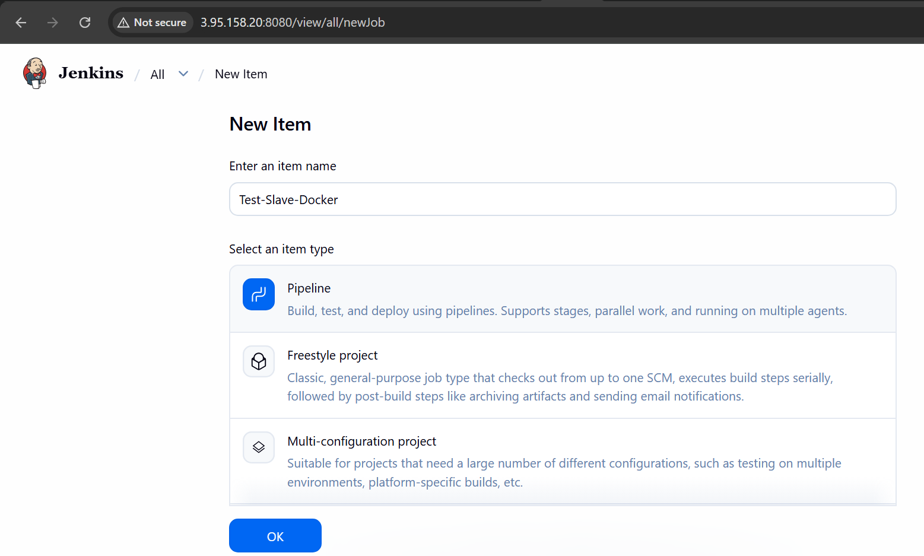
Under Pipeline → Definition, select: Pipeline script
Paste: pipeline {
agent {
label 'slave-01'
}
stages {
stage('Check Host') {
steps {
sh '''
echo "===== HOSTNAME ====="
hostname
echo "===== USER ====="
whoami
'''
}
}
stage('Check Docker') {
steps {
sh '''
echo "===== DOCKER VERSION ====="
docker --version
echo "===== DOCKER INFO ====="
docker info
'''
}
}
stage('Check Git') {
steps {
sh '''
echo "===== GIT VERSION ====="
git --version
'''
}
}
}
}
Click: Save → Build Now
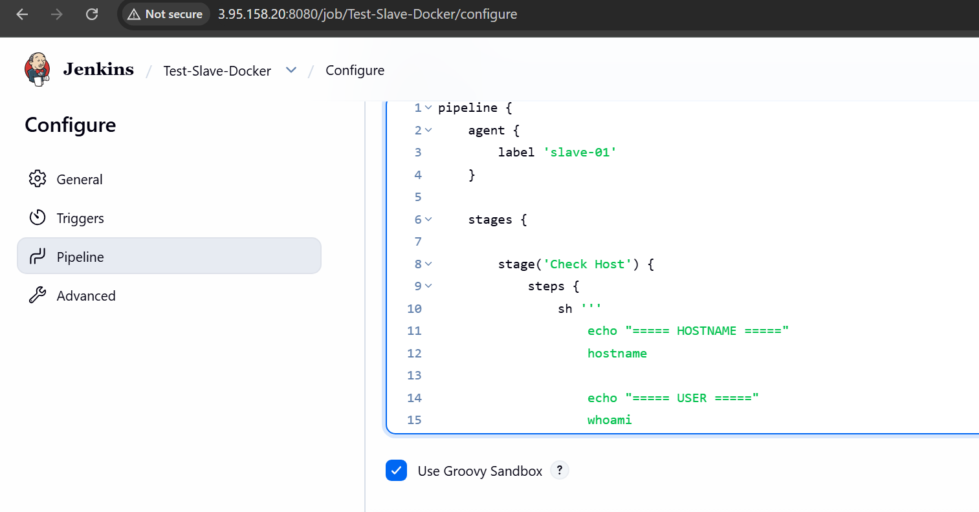Part 4 — Check the test result
Open: Build #1 → Console Output
We want to see something similar to:
===== HOSTNAME =====
ip-10-0-2-112
===== USER =====
jenkins
===== DOCKER VERSION =====
Docker version ...
===== GIT VERSION =====
git version ...
Most importantly:
docker info
must work.
If you get this: permission denied while trying to connect to the Docker daemon socket
then Docker is installed, but the Jenkins user doesn't have permission.
In that case, we'll fix it before continuing.
Don't proceed until this test succeeds.
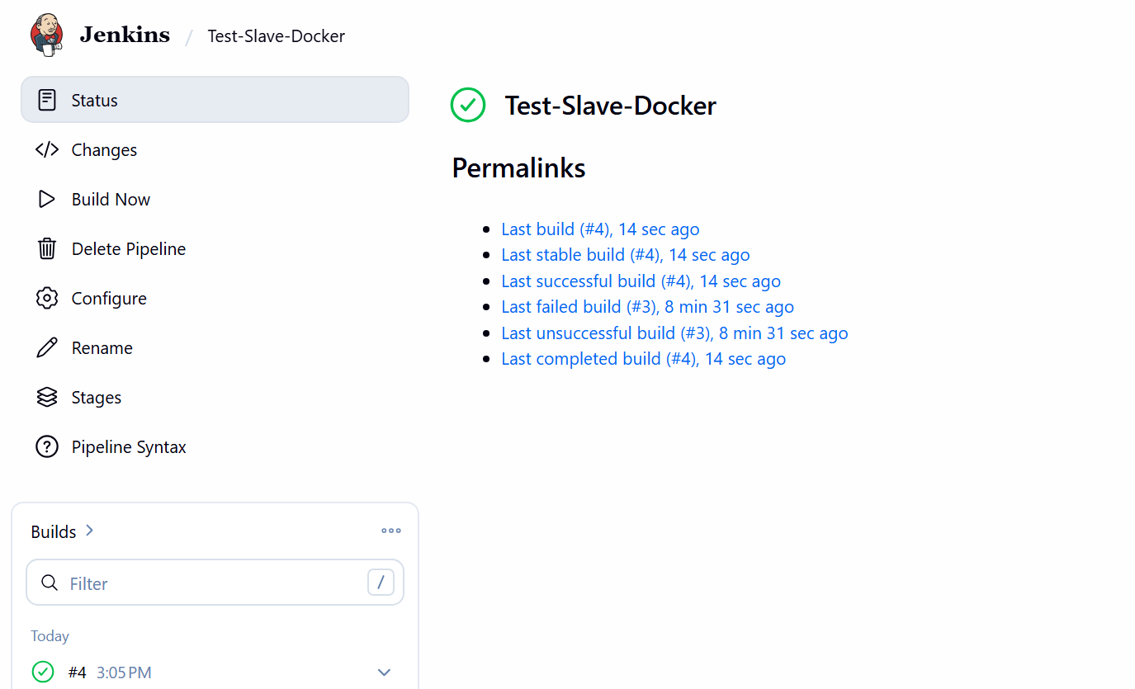

Part 5 — Create Docker Hub Repository
You already have the Docker Hub account: narayanakl
Go to Docker Hub and create a repository: jenkins-docker-demo
So the final image name will be: narayanakl/jenkins-docker-demo:1.0
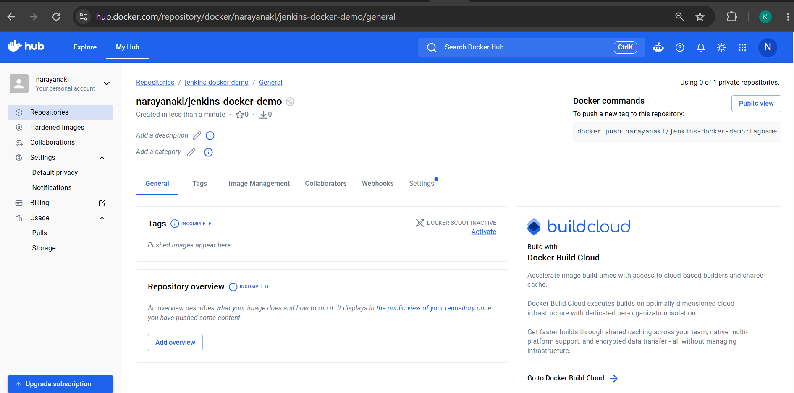Part 6 — Create Docker Hub Access Token
In Docker Hub: Account Settings → Personal access tokens → Generate new token
Use a description such as: jenkins-task8
Give it permission to push images.
Copy the generated token.
⚠️ Do not send the token here and do not put it directly into the Jenkinsfile.
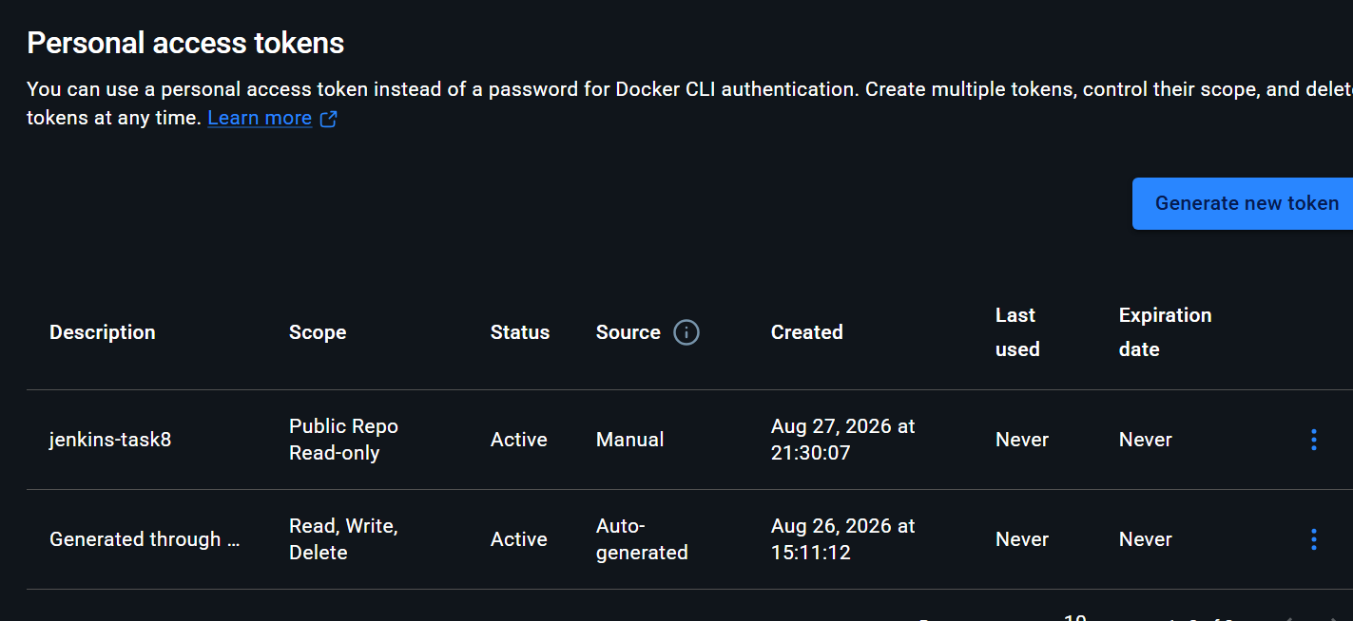Part 7 — Add Docker Hub credentials to Jenkins
Go to: Jenkins → Manage Jenkins → Credentials
Then: System → Global credentials → Add Credentials
Select: Kind: Username with password
Enter: Username: narayanakl
For password: <your Docker Hub access token>
Set: ID: dockerhub-credentials
Description: Docker Hub Push Credentials
Click: Create
You should now have: dockerhub-credentials
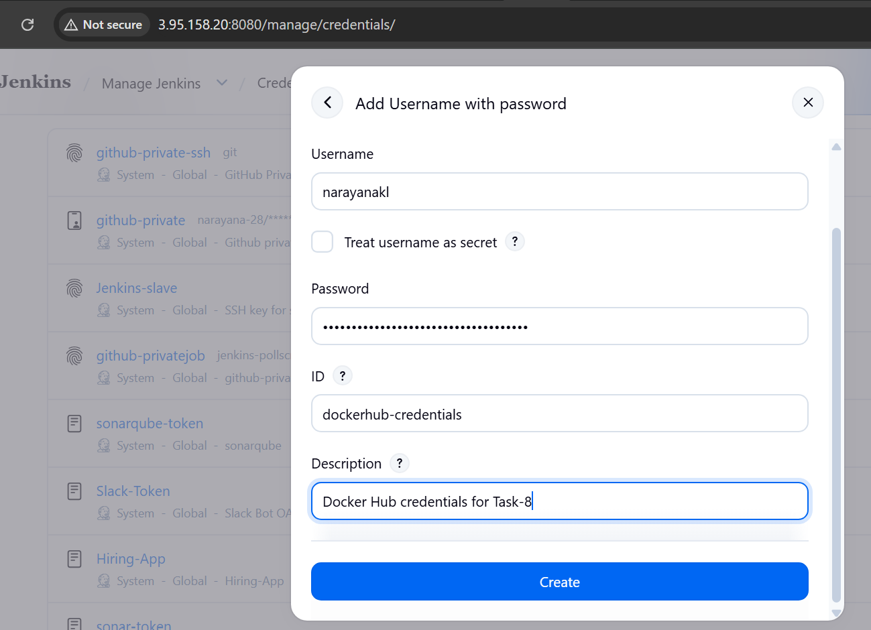
Part 8 — Create the Jenkins Pipeline Job
Go to: Jenkins Dashboard → New Item
Enter: DockerHub-Pipeline
Select: Pipeline
Click: OK
Scroll to the Pipeline section.
For: Definition
select: Pipeline script
We will initially put the Jenkinsfile directly into Jenkins so that we can verify the task easily.
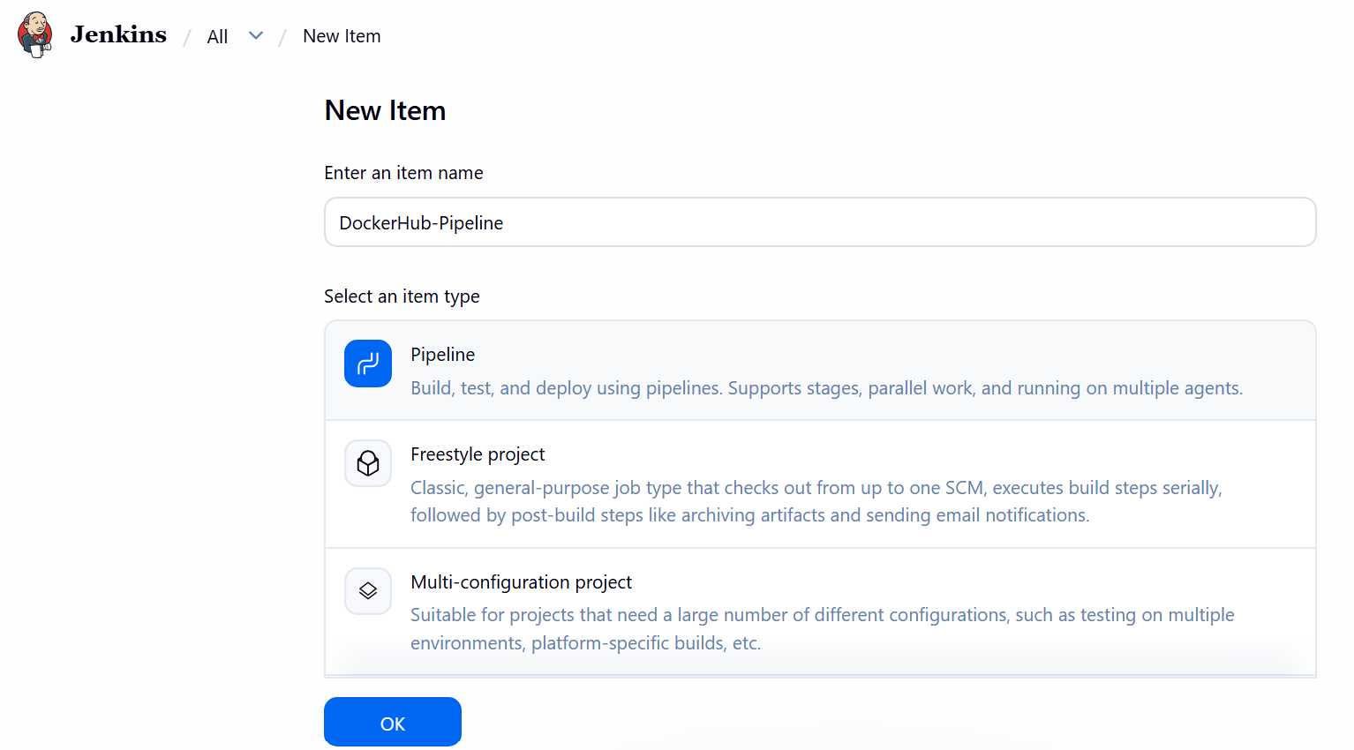
Part 9 — Prepare the Application on GitHub
For Task-8, we'll use your existing GitHub project: https://github.com/narayana-28/hiring-app.git
The important requirement is that the repository should contain a Dockerfile.
Before creating the pipeline, we need to know whether your hiring-app repository already has a Dockerfile.
On slave-01, you can check with:
git clone https://github.com/narayana-28/hiring-app.git
Then: cd hiring-app
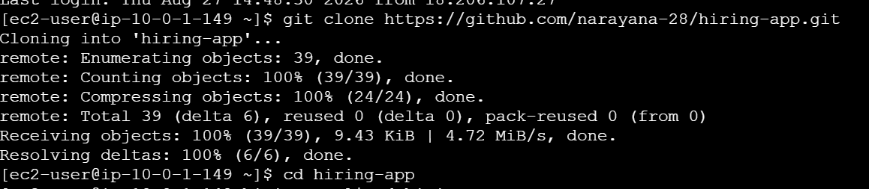
Check: ls -la
And: find . -maxdepth 2 -name 'Dockerfile' -o -name 'dockerfile'
If Dockerfile exists
Good. We'll use it.
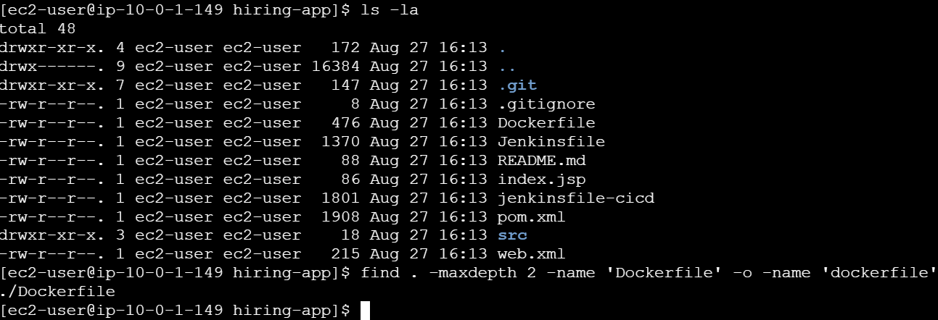
If Dockerfile does not exist
We'll create one appropriate for the application before running the pipeline.
Don't create a random Dockerfile yet, because your hiring-app is a Java/Maven application and the correct Dockerfile depends on how we want to package/run it.

Part 10- Replace the Dockerfile
Run: cat > Dockerfile <<'EOF'
FROM nginx:latest
LABEL maintainer="Narayana"
COPY index.html /usr/share/nginx/html/index.html
EXPOSE 80
CMD ["nginx", "-g", "daemon off;"]
EOF
Verify: cat Dockerfile
It should show: FROM nginx:latest
LABEL maintainer="Narayana"
COPY index.html /usr/share/nginx/html/index.html
EXPOSE 80
CMD ["nginx", "-g", "daemon off;"]
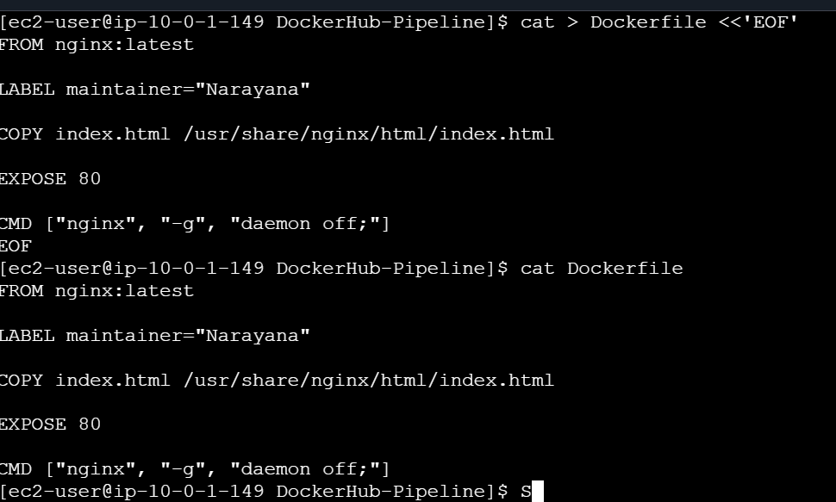
Create the HTML file
Run: cat > index.html <<'EOF'
<!DOCTYPE html>
<html>
<head>
<title>Jenkins Docker Hub Pipeline</title>
</head>
<body>
<h1>Docker Image Built by Jenkins</h1>
<h2>Task 8</h2>
<p>Image successfully built and pushed to Docker Hub!</p>
</body>
</html>
EOF
Check: cat index.html
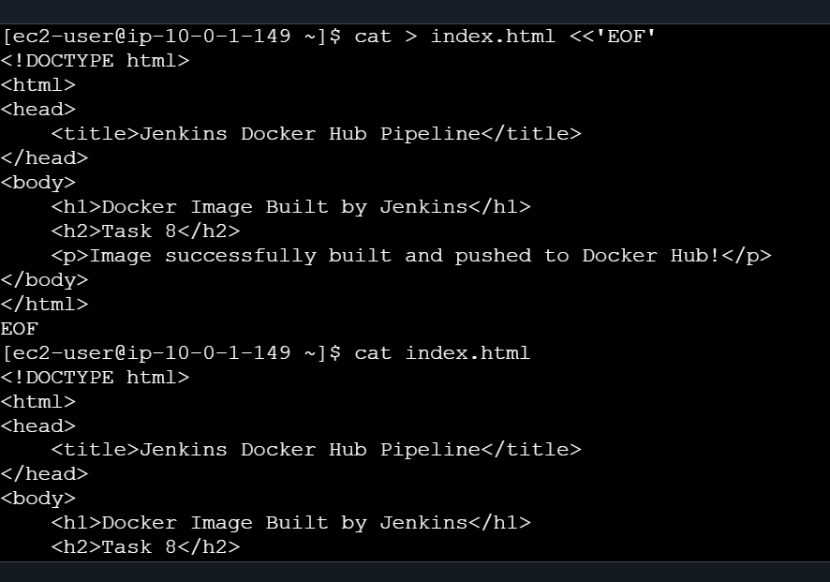
Build manually
Now test the Dockerfile before running Jenkins: docker build -t narayanakl/jenkins-docker-demo:1.0 .
You should not see any reference to: 54.157.190.6:8081
The build should pull: nginx:latest
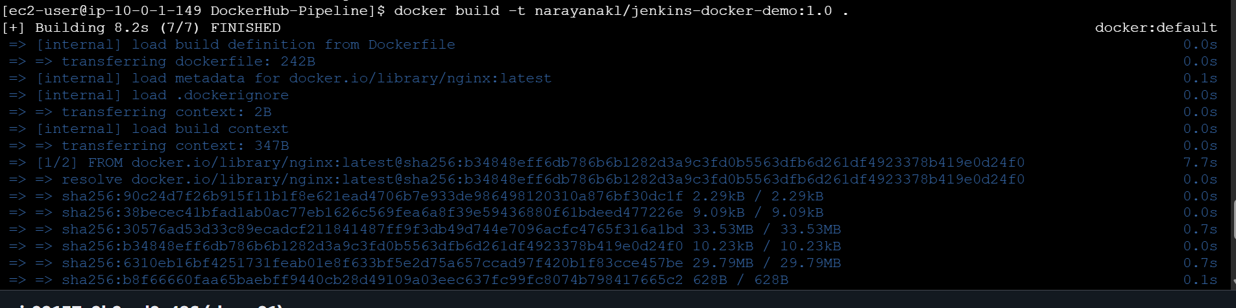
Then check: docker images | grep jenkins-docker-demo
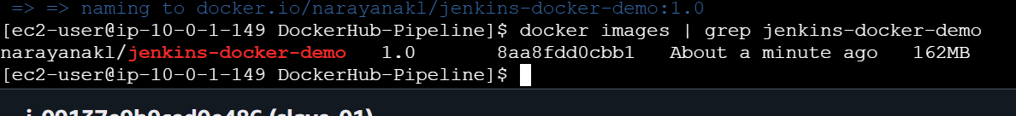
Test the image
Run: docker run -d \
--name jenkins-docker-test \
-p 8089:80 \
narayanakl/jenkins-docker-demo:1.0
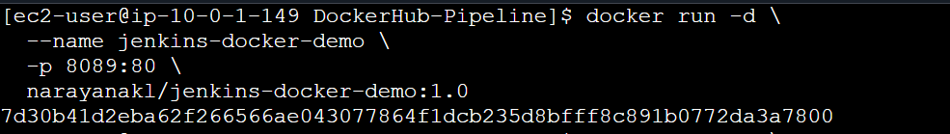
Test: curl http://localhost:8089
You should see:<h1>Docker Image Built by Jenkins</h1>
<h2>Task 8</h2>
<p>Image successfully built and pushed to Docker Hub!</p>
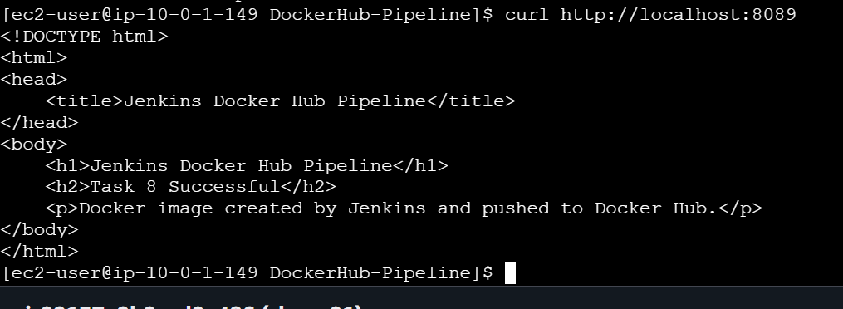
Then remove the test container: docker rm -f jenkins-docker-test

Part 11 — Jenkins Pipeline
Once the Dockerfile is available, put this pipeline into the Pipeline Script box.
For the first version, we'll use a simple pipeline:
pipeline {
agent {
label 'slave-01'
}
environment {
IMAGE_NAME = 'narayanakl/jenkins-docker-demo'
IMAGE_TAG = '1.0'
}
stages {
stage('Checkout') {
steps {
git branch: 'main',
url: 'https://github.com/narayana-28/hiring-app.git'
}
}
stage('Docker Build') {
steps {
sh '''
echo "===== DOCKER VERSION ====="
docker --version
echo "===== BUILDING IMAGE ====="
docker build -t ${IMAGE_NAME}:${IMAGE_TAG} .
'''
}
}
stage('Docker Login') {
steps {
withCredentials([
usernamePassword(
credentialsId: 'dockerhub-credentials',
usernameVariable: 'DOCKER_USERNAME',
passwordVariable: 'DOCKER_PASSWORD'
)
]) {
sh '''
echo "$DOCKER_PASSWORD" | docker login \
--username "$DOCKER_USERNAME" \
--password-stdin
'''
}
}
}stage('Docker Push') {
steps {
sh '''
echo "===== PUSHING IMAGE ====="
docker push ${IMAGE_NAME}:${IMAGE_TAG}
'''
}
}
stage('Verify Image') {
steps {
sh '''
echo "===== VERIFYING IMAGE ====="
docker images ${IMAGE_NAME}
'''
}
}
}
post {
always {
sh 'docker logout || true'
}
success {
echo 'Docker image successfully built and pushed to Docker Hub!'
}
failure {
echo 'Docker image pipeline failed.'
}
}
}
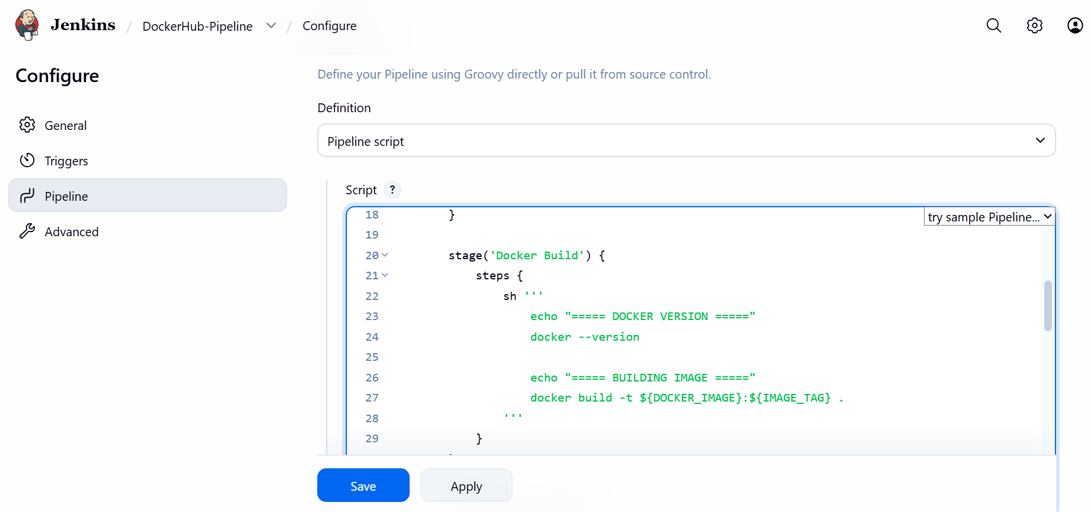

Part 12 — Important: GitHub Branch
The pipeline currently uses: branch: 'main'
Your repository may use main.
You can verify from slave-01: git ls-remote --heads https://github.com/narayana-28/hiring-app.git
If you see: refs/heads/main
then leave: branch: 'main'
If you see another branch, we'll change it.
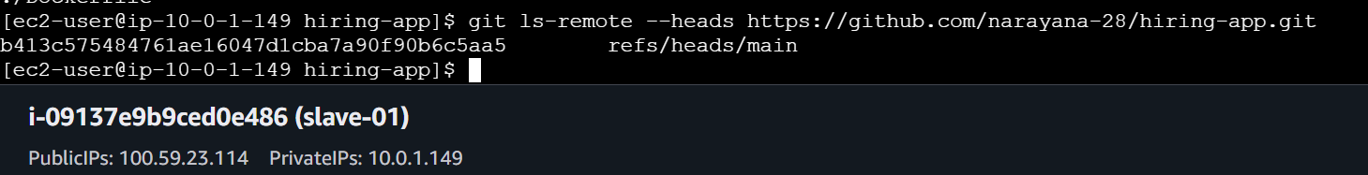
Part 13 — Save the Pipeline
After pasting the Jenkinsfile: Click: Save
Then: Build Now
Watch the console.
The stages should appear approximately as: [Pipeline] stage
[Pipeline] { (Checkout)
then: [Pipeline] stage
[Pipeline] { (Docker Build)
then: [Pipeline] stage
[Pipeline] { (Docker Login)
then: [Pipeline] stage
[Pipeline] { (Docker Push)
then: [Pipeline] stage
[Pipeline] { (Verify Image)

Part 14 — Expected Docker Build
The important output should contain:
===== DOCKER VERSION =====
Docker version 25.0.14
Then:
===== BUILDING IMAGE =====
followed by Docker BuildKit output.
At the end:
Successfully tagged narayanakl/jenkins-docker-demo:1.0

Part 15 — Expected Docker Login
You should see something similar to:
Login Succeeded
The password/token itself should never appear in the console.
Jenkins masks credentials.

Part 16 — Expected Docker Push
You should see:
===== PUSHING IMAGE =====
and Docker layers being uploaded.
Finally something similar to:
1.0: digest: sha256:xxxxxxxx...
This is the important confirmation that the image reached Docker Hub.
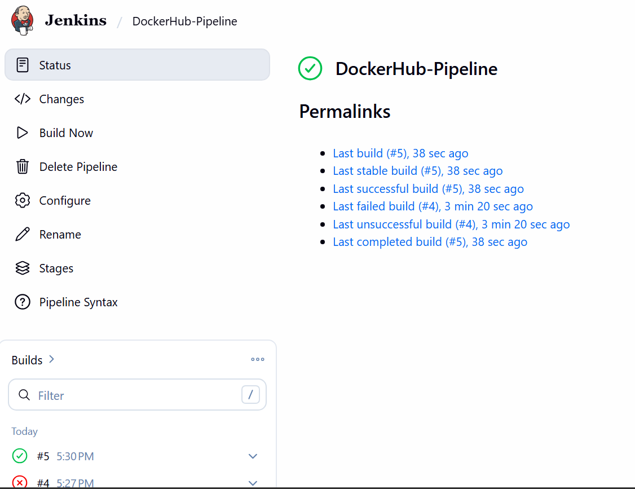
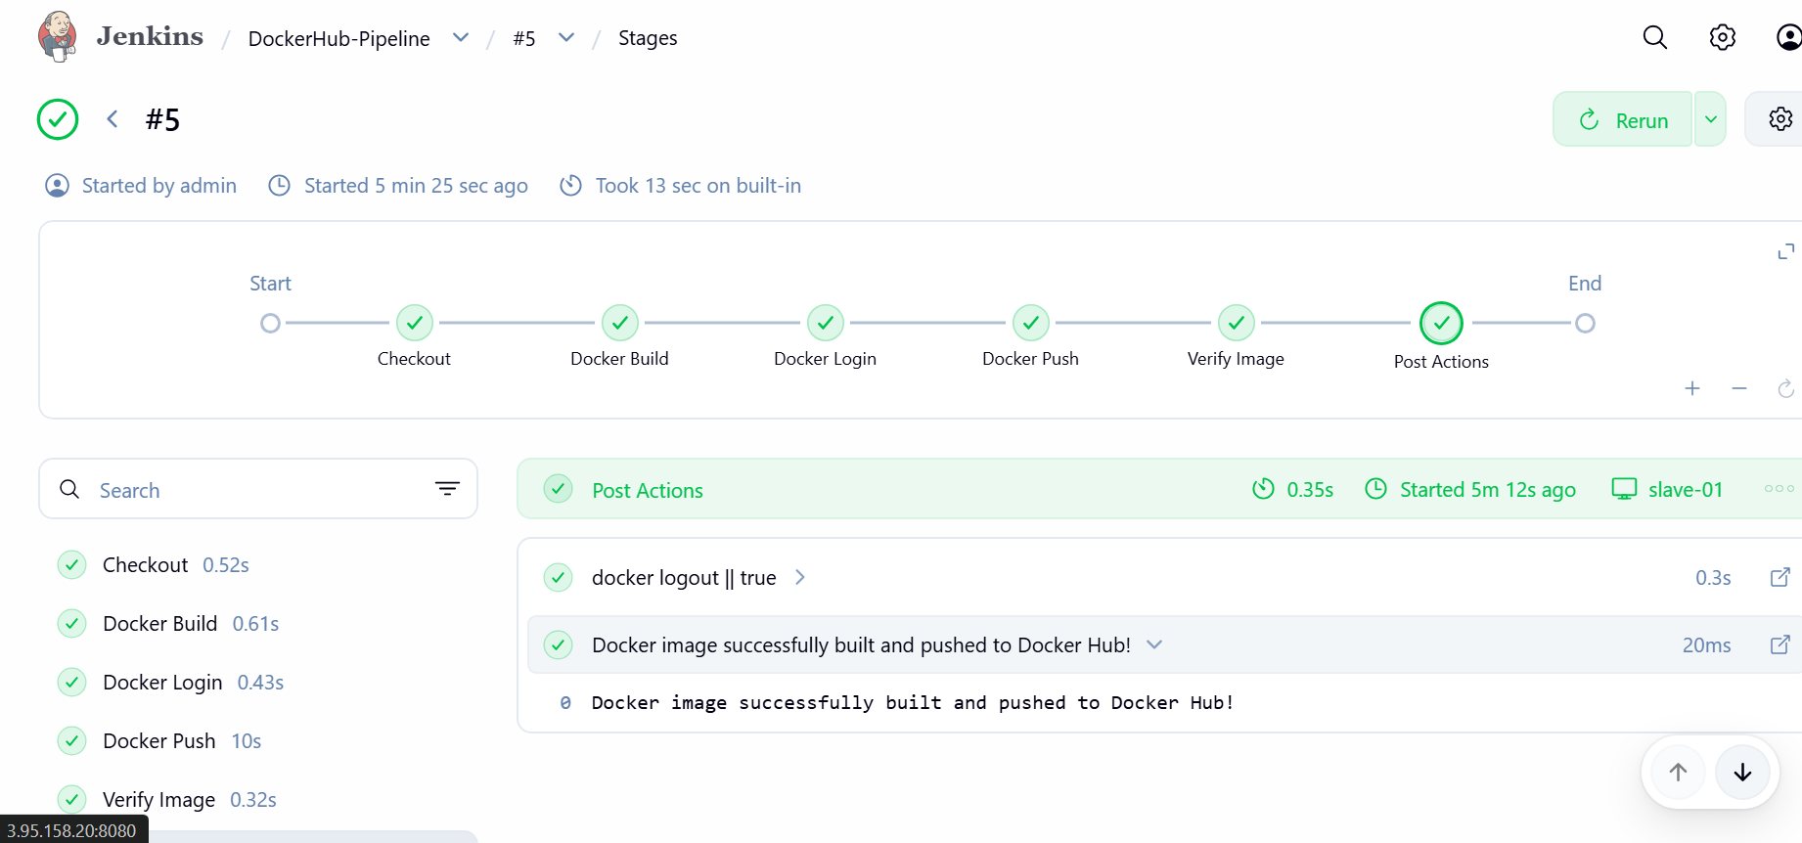

Part 17 — Verify on Docker Hub
Open your Docker Hub repository:
narayanakl/jenkins-docker-demo
You should see: Tag: 1.0
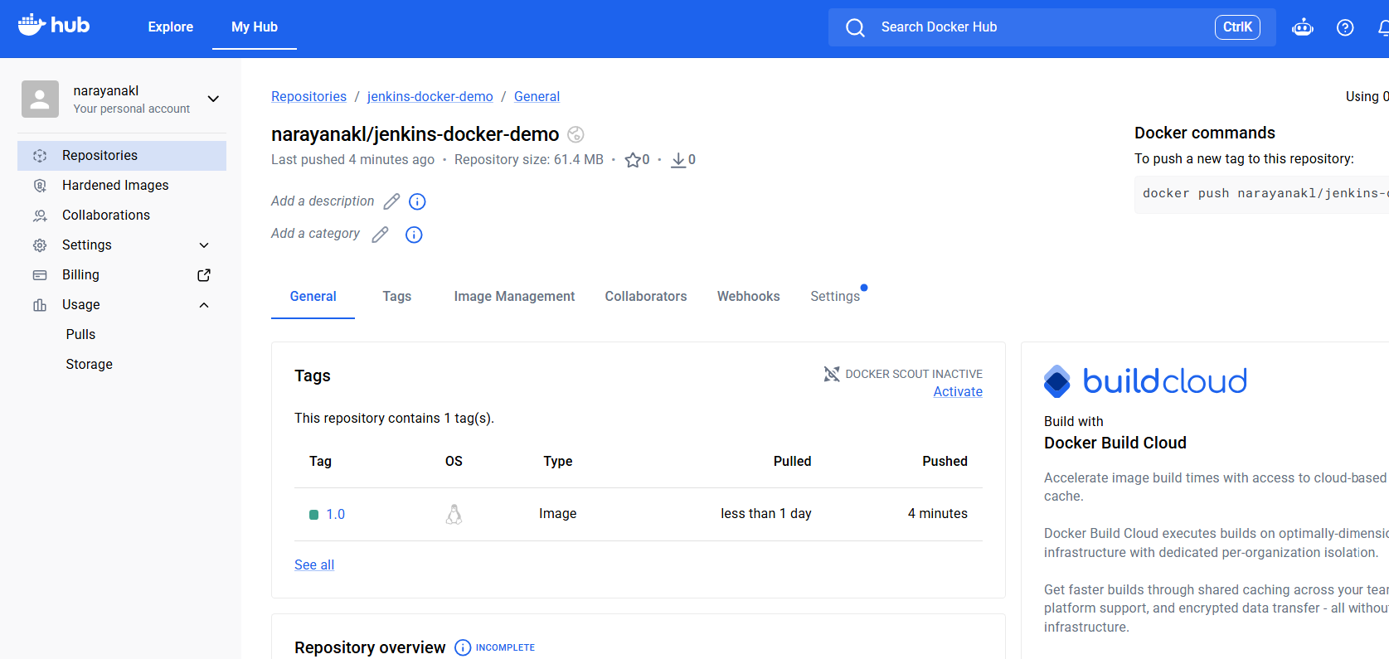
Then from slave-01 test: docker pull narayanakl/jenkins-docker-demo:1.0
Expected: 1.0: Pulling from narayanakl/jenkins-docker-demo
...
Status: Downloaded newer image for ...
Part 18 — Verify the Image Locally
Run: docker images | grep jenkins-docker-demo
Expected: narayanakl/jenkins-docker-demo 1.0 <IMAGE_ID> ...
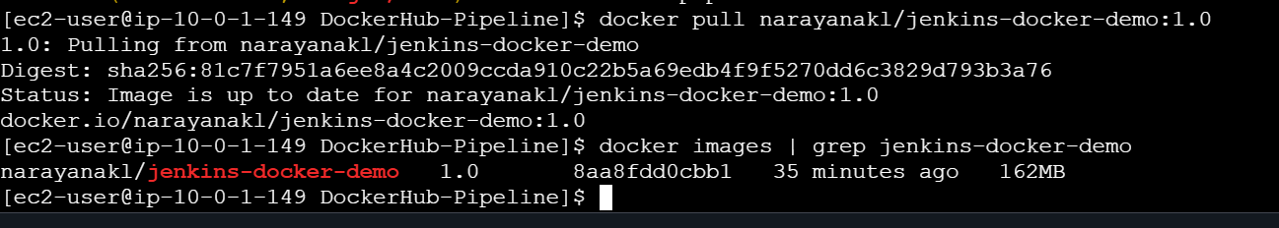
Part 19 — Task-8 Completion
Your final flow will be:
GitHub
│
│ checkout
▼
Jenkins Master
│
│ assigns pipeline
▼
slave-01
│
├── docker build
│
├── docker login
│
└── docker push
│
▼
Docker Hub
│
▼
narayanakl/jenkins-docker-demo:1.0

